Iowa Balance of STate: sample governance models

The Iowa Balance of State CoC requested assistance from HUD to facilitate a strategic planning process to review its current governance structure and determine if a different configuration would better serve the needs of the CoC. Involved in this request is determining which entities are best suited to: act as the CoC board; act as the collaborative applicant; provide administrative support to the CoC Board; and provide leadership staffing to the CoC Board.

Below is information on the current Iowa Balance of State CoC structure and how other Balance of State CoCs have designed their governance structures to best meet local need.

# Current iowa balance of state governance Structure

The Iowa Balance of State Continuum of Care (Iowa BoS CoC) covers 96 of the state’s 99 counties. In 2017, the CoC began to regionalize service efforts by dividing the CoC into six “coordinated regional systems of care.”[1] In Fiscal Year 2016, the Iowa BoS CoC received $4,755436 in CoC Program funds for its 25 CoC-funded projects, including $218,116 in planning funds.

The Iowa Council on Homelessness acts as the CoC Board for the Iowa BoS CoC. This entity was established in 2008 and is governed by Iowa Code Chapter 16.2D.[2] All 38 members of the Iowa Council on Homelessness are appointed by the Governor, with 12 of those seats reserved for members representing relevant state departments. The remaining 26 seats are comprised of members from the general public who apply for appointment through the Governor’s office. Within the 26 general public seats, the following are required: five seats must be members who are homeless or formerly homeless; one seat must represent the Iowa State Association of Counties; one seat must represent the Iowa League of Cities.

The Iowa Council has several standing committees and numerous informal working groups focused on specific issue areas. The Continuum of Care Committee, one of the three formal standing committees, is tasked with “assist[ing] in the development and maintenance of a statewide continuum of care to end homelessness,” which includes developing the Balance of State CoC’s Consolidated Application.

The Iowa Finance Authority acts as the CoC’s collaborative applicant. Under this role, the organization is formally tasked with conducting administrative functions (supporting and staffing meetings), acting as the Iowa State ESG grantee, overseeing the CoC grant application process, and coordinating and preparing portions of the State of Iowa Five-Year Consolidated Plan and related action plans and reports. A separate entity, the Institute for Community Alliances (ICA), acts as the HMIS Lead for the Iowa BoS CoC.

# Missouri Balance of State

The Missouri Balance of State Continuum of Care (MO BoS CoC) includes the 101 counties outside of the metropolitan areas of Missouri and is broken into 10 regions. In Fiscal Year 2016, the CoC received $4,942,202 in CoC Program funds for its 34 CoC-funded projects, including $152,726 in planning funds.

In 2017, the MO BoS CoC underwent a process to significantly alter its governance structure to allow for greater local control of CoC-related decisions.

Pre-2017 Governance Structure

Prior to the 2017 restructuring, the MO BoS CoC governance was structured similar to that of the Iowa Balance of State. The Missouri Governor’s Committee to End Homelessness (GCEH) acted as the governing body for the MO BoS CoC (and continues to exist following the BoS CoC governance restructuring). Established by executive order in 1987, the GCEH is comprised of at least 20 members appointed by the Governor to address the issue of homelessness throughout the state of Missouri. Seven state agencies, several statewide non-profits, and one representative from each CoC within the state hold a seat on the Committee.

At the time, the Balance of State CoC Committee acted as one of the standing subcommittees of the GCEH. This Committee was comprised of representatives from the CoC’s Collaborative Applicant, the HMIS lead, state agencies, and at least one member from each of the 10 regions in the Balance of State. It was tasked with conducting general MO BoS CoC functions, such as developing and submitting the Collaborative Application, conducting the PIT count, and overseeing Regional Housing Team Meetings. The Regional Housing Team Meetings took place in every region at least quarterly and acted as regional planning meetings. However, the GCEH held ultimate approval over MO BoS CoC decisions.

Current governance structure

On June 2, 2017, the MO BoS CoC approved a new governance charter, restructuring the BoS CoC Board as an independent and self-governing body. The current Board is comprised of between 11 and 19 members.[3] Each of the ten regions within the CoC holds at least one seat; representatives from each region are nominated and elected at the regional level. There are also a maximum of nine at-large board seats, which are intended to represent diverse backgrounds and geography from within the CoC. The at-large members are elected through a CoC-wide nomination and election process. In addition, a member of the Collaborative Applicant (Missouri Housing Development Corporation) and a member of the HMIS lead agency (Institute for Community Alliances) serve as ex-officio, non-voting members of the Board.

Each year, the Board elects an Executive Committee, comprised of a Chair, Vice Chair, and Secretary. It also operates several standing committees, including: Grants, Membership, Data, Coordinated Entry, and Special Populations.

Each region is encouraged to hold local meetings to discuss ongoing issues and act as a platform to develop regional opinions to provide to the full CoC. The MO BoS CoC holds semiannual meetings facilitated by the collaborative applicant and HMIS lead agencies, which act as a platform for the CoC to solicit and consider opinions from organizations throughout the entire continuum. In addition, the MO BoS CoC utilizes its various committees to provide on-the-ground input from all ten regions.

# Ohio balance of state

The Ohio Balance of State Continuum of Care (OH BoSCoC) covers 80 counties, which are divided into 17 Homeless Planning Regions (HPRs). In Fiscal Year 2016, the OH BoSCOC received $16,189,733 in CoC Program Funds for its 96 projects, including $459,251 in planning funds.

The Ohio BoSCoC Board is the primary planning body for the Ohio BoSCoC. Membership, which is limited to no more than 30 individuals, includes one locally-determined representative from each HPR Executive Committee (discussed below); at-large representatives, which can include individuals representing certain special populations, state agencies, etc.; at least one Ohio Development Services Agency (ODSA) representative; and at least one representative from the Coalition on Homelessness and Housing in Ohio (COHHIO, which acts at the collaborative applicant and HMIS lead). While both ODSA and COHHIO may appoint more than one representative to serve on the board, only one member from each agency is permitted to vote.

The CoC holds semiannual meetings of the full membership, which includes any organization or person who attends meetings of the Ohio BoSCoC HPR committees/workgroups, local CoC groups, or OH BoSCoC committees/workgroups and/or participates in local homeless planning efforts. Each HPR is allotted three representatives permitted to cast a vote on a business matter presented to the full OH BoSCoC during these meetings.

The OH BoSCoC has eight standing committees that act as workgroups but cannot take action on behalf of the CoC or Board without Board approval. Membership requirements for each group are outlined in the CoC’s governance charter; for most workgroups, membership is solicited from the CoC every two years and the roster for each workgroup is approved by the Board.

Each HPR is responsible for planning and coordinating local homeless systems and programs, including the implementation of a regional coordinated entry system. The HPRs are also given authority to determine how to define their membership, although they are expected to include all homeless service organizations receiving state or federal funds, and organize/structure themselves to meet the responsibilities required by the OH BoSCoC. At a minimum, they are required to form a Regional Executive Committee to oversee all of the work of the HPR.

# North Carolina Balance of State

The North Carolina Balance of State Continuum of Care (NC BoS CoC) covers 79 of the 100 counties in the state. Due to the state’s size and the number of counties included in the NC BoS CoC, the CoC is organized into 13 Regional Committees that coordinate local work and planning. In Fiscal Year 2016, NC BoS CoC received $8,409,964 in CoC Program funds for its 46 projects, including $315,343 in planning funds.

The NC BoS CoC Steering Committee serves as the primary decision-making body of the CoC and is responsible for all matters pertaining to the structure, purpose, performance and activities of the CoC. The Steering Committee meets monthly via conference call and at least one time per year in person. The Committee is staffed by the North Carolina Coalition to End Homelessness, which also acts as the Collaborative Applicant for the CoC.

The Steering Committee is comprised of between 20 and 26 members, which includes both Regional Committee seats and at-large seats. Each of the 13 Regional Committees elect one Regional Lead to serve on the Steering Committee, along with an alternate to stand in for the lead in his or her absence. In addition, the Steering Committee must have at least 7, and may have as many as 13, at-large seats.[4] These at-large seats are elected by the other members of the Steering Committee and hold a one-year term. There are three categories of at-large seats, which include: at least 1, up to 2, people with lived experience of homelessness; at least 3, up to 6, representatives from designated departments of the North Carolina State Government; and at least 3, up to 5, “other” at-large seats, which can include representatives from the health care sector, business sector, public housing agency, domestic violence services sector, legal services, or youth services or advocacy sector. Each Steering Committee member gets one vote in voting matters.

The Steering Committee oversees the work of a variety of subcommittees and workgroups. It currently has three standing subcommittees: Coordinated Assessment Exchange, Veterans Subcommittee, and Funding and Performance Subcommittee. In addition, it has two standing subcommittees that meet on as-needed basis regarding the CoC Collaborative Application: Scorecard Committee and the Project Review Committee. A Coordinated Assessment Council is appointed by the Steering Committee to review and approve coordinated entry plans written by Regional Committees. In addition, the Steering Committee has the authority to create short-term, outcome-focused working groups on an as-needed basis.

At the local level, each Regional Committee is required to have its own regular meetings to address issues relevant to the region. They are also assigned various responsibilities by the NC BoS CoC, including: designing and administering a coordinated assessment system (within the parameters set by the CoC); electing leadership positions to the Steering Committee, its subcommittees, and to lead local initiatives; collecting and providing information needed to complete the Point in Time count and CoC application to HUD; and various other CoC-Program compliance tasks.

Below is an organizational chart used by the CoC to help visualize the governance structure.

NC%20BOS/BoS-CoC-Organization-7.27.12.pdf

# Texas Balance of State

The Texas Balance of State (TX BoS CoC) is comprised of 215 counties throughout the state of Texas. Within those counties, approximately 25 regional Local Homeless Coalitions (LHCs) conduct local CoC planning. In Fiscal Year 2016, the TX BoS CoC received $6,499,737 in CoC Program funds for its 22 CoC-funded projects, including $1,039,697 in planning funds.

The TX BoS CoC elects a CoC Board to act on its behalf and serve as the primary decision-making body for the CoC. The Board consists of 15 members elected by the full CoC membership at the fall CoC general meeting. Each seat has a stakeholder designation, and the person filling that seat must represent the group designated for that seat by: 1) being a member of that group; working for an agency/organization that serves the designated group; and/or 3) clearly representing the interests of that group. The seats are designated as follows:

**Seat 1**: Person with lived experience

**Seat 2**: Homeless veterans

**Seat 3**: Chronically homeless persons

**Seat 4**: Homeless families

**Seat 5**: Homeless youth

**Seat 6**: Victim services

**Seat 7**: Mental/behavioral health

**Seat 8**: Health/medical

**Seat 9**: Local government

**Seat 10**: Emergency Solutions Grant (ESG) Recipient

**Seat 11**: Public Housing Agency

**Seat 12**: Law enforcement/corrections

**Seat 13**: Business

**Seat 14**: Faith community or faith-based agency/organization

**Seat 15**: Texas Interagency Council for the Homeless (TICH) or State government agency

Anyone living and/or working within the TX BoS CoC geographic area that meets the representation requirements may be nominated for a seat. Board members are nominated and elected by the CoC general membership. The CoC Board meets at least quarterly, and special meetings are held as needed. The Board is staffed by the Texas Homeless Network, which also serves as the Collaborative Applicant.

The 25 Local Homeless Coalitions (LHCs) act as the lead workgroups responsible for managing community planning, coordination, and evaluation at the local level. The LHCs include representatives of relevant organizations in the community and are responsible for planning for the use of CoC resources and coordinating the funds with other resources in the community. In addition, the CoC designates standing committees, and may have ad hoc committees as needed, to fulfill CoC requirements and enhance the functioning and effectiveness of the CoC.

Below is an organizational chart used by the CoC to help visualize the governance structure.

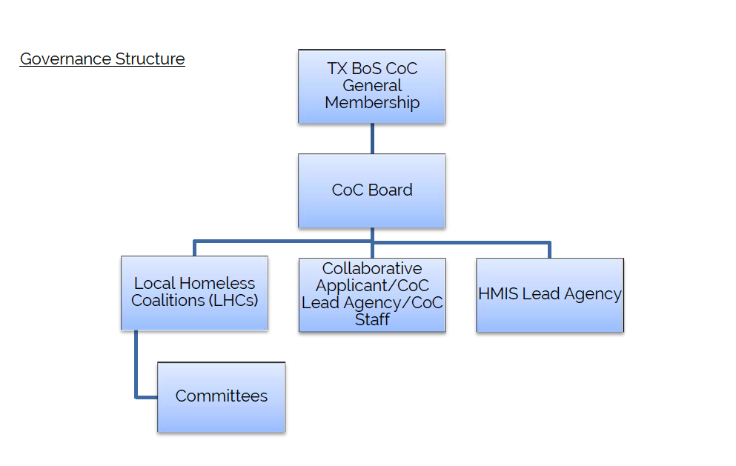

1. This regionalization is not formalized in the CoC’s current governance documents, and was instituted to facilitate the adoption of a coordinated entry system for the CoC.
2. The state code does briefly mention the Continuum of Care competition in Section 9(c): “The council shall assist in the completion of the state’s [C]ontinuum of [C]are application to the United States [D]epartment of [H]ousing and [U]rban [D]evelopment.”
3. The current, newly-established Board includes the maximum 19 members.
4. At-large seats were added in 2017 after a workgroup drafted, and the Steering Committee approved, a proposal for their addition.