SAVE THE DATE
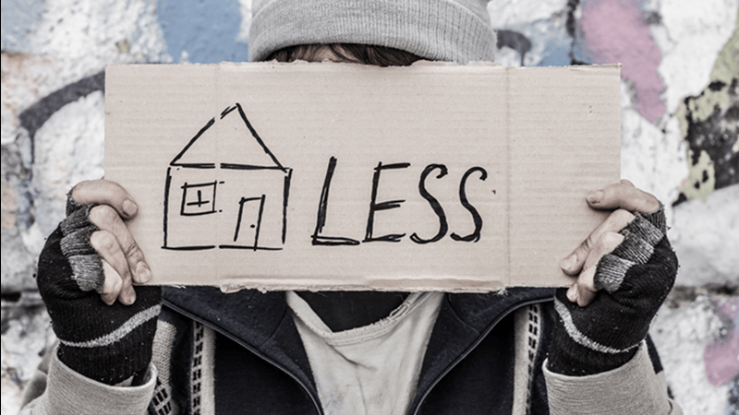

Iowa/Nebraska Peer-To-Peer
Homelessness Symposium
June 9-10, 2020

Des Moines University
Des Moines, Iowa

