Iowa Balance of State Strategic Plan to End Veteran Homelessness
Draft
Introduction

In 2010, the United States Interagency Council on Homelessness (USICH) introduced Opening Doors, the first federal strategic plan to prevent and end homelessness. The plan set key goals that included ending homelessness among veterans by 2015. During the first five years of the plan’s implementation, many partners came to the table to produce measurable reductions in veteran homelessness, including the U.S. Department of Veterans Affairs (VA), the U.S. Department of Housing and Urban Development (HUD), and many local homeless service providers and community partners across the Continuums of Care (CoC). In October 2015, the U.S. Interagency Council on Homelessness and its federal partners released the Criteria for Achieving the Goal of Ending Veteran Homelessness to create a comprehensive, consistent approach to evaluating whether a community has ended homelessness for Veterans. The Criteria, and the related Benchmarks, recognize that Veterans will continue to experience housing crises and focus on whether systems have made the necessary changes to make homelessness for Veterans rare, brief, and non-recurring.

Progress to-date in the Iowa Balance of State (BoS) Continuum of Care (CoC), has been made with coordinated efforts through the VA, Public Housing Authorities (PHAs), Veterans Services Officers (VSOs), and community partners across the CoC, including those who administer the Supportive Services for Veteran Families (SSVF) grants and manage Grant and Per Diem (GPD) transitional housing for Veterans.
Great strides have been made with the introduction of Veterans Affairs Supportive Housing (VASH) vouchers in the CoC. The collaborative effort provides vouchers administered through PHAs in Iowa City, Cedar Rapids, Davenport, Waterloo and Mason City with the local VA providing supportive services to those eligible Veterans housed through the HUD-VASH program.
The SSVF grants are currently administered by four community partners in the Iowa BoS CoC. The SSVF program provides case management and supportive services to prevent the imminent loss of a Veteran’s home or identify a new, more suitable housing situation for the individual and his or her family; or to rapidly re-house Veterans and their families who are homeless and might remain homeless without this assistance. The four community partners, Humility Homes and Services, Inc., Primary Health Care, Hawkeye Area Community Action Programs (HACAP), and Family Alliance for Veterans of America (FAVA), span 58 of the 96 counties across the Iowa BoS CoC.
There are additional community partners who receive capital grants and per diem payments to develop and operate transitional housing and/or service centers for Veterans who are homeless. In the Iowa BoS CoC, transitional housing for Veterans is available at Shelter House, Humility Homes and Services, Inc. and Willis Dady, while Goodwill of the Heartland operates a service center for homeless, at-risk, or recently housed Veterans seeking employment opportunities.
In March of 2016 Des Moines and Polk County CoC announced their declaration of an end to Veteran Homelessness, proving the goal was achievable in the state of Iowa. Through their hard work and determination, effective lessons and strategies were shared giving momentum to other cities around Iowa to seek this same success.
A major turning point in ending homelessness started in 2017 with the implementation of coordinated entry in the BoS CoC. Coordinated Entry is considered one of the many interventions in a community’s united effort to end and prevent homelessness. Coordinated entry refers to the process used to assess and assist in meeting the housing needs of people at-risk of homelessness and people experiencing homelessness. The implementation of coordinated entry is considered national best practice, with the system goals aligning with the Federal Criteria and Benchmarks for ending homelessness. Twelve coordinated services regions operate covering 71 counties. With the leadership and expertise of the Institute of Community Alliances (ICA), the Iowa BoS CoC’s Homeless Management Information System (HMIS) lead, the CoC is well on its way to developing a complete and comprehensive by name list that includes all Veterans who are literally homeless.
In 2018 the United States Interagency Council on Homelessness (USICH) released the updated Federal Strategic Plan to Prevent and End Homelessness. The plan titled, “Home, Together,” celebrates progress made since 2010 across the country but also outlines the significant work ahead that communities need to continue to commit to reach our shared national goal of ending homelessness. The updated plan, like the 2010 plan, continues to list the first goal for communities as ending Veteran Homelessness.
This plan describes the advancing efforts needed to achieve an end to homelessness for Veterans in Iowa’s Balance of State Continuum of Care (BoS). In line with the federal goals outlined in Opening Doors and Home, Together, the Iowa BoS CoC has determined that ending Veteran homelessness in our CoC means when Veteran homelessness does occur, it is rare, brief, and non-recurring. To achieve this, the Iowa BoS is committed to the principles of Housing First, which means our system is primarily focused on quick placement into permanent housing, respecting Veteran choice, and targeting our resources to those with greatest needs.

We echo the words of Home, Together that define the significance of the plan’s title. We are hopeful community leaders and partners will reaffirm their commitment to end homelessness starting with ending Veteran Homelessness “Because we know that the only true end to homelessness is a safe and stable place to call home. And, Because the causes of homelessness are complex, and the solutions are going to take all of us working together, doing our parts, strengthening our communities.”

Figure 1.0
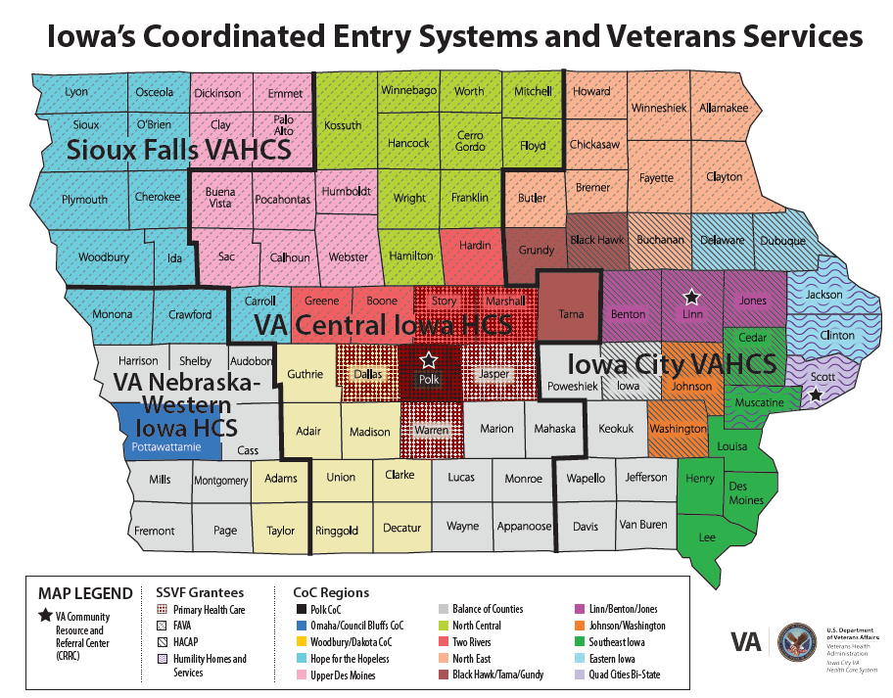
Figure 1.0 depicts a map of Iowa that identifies the four CoCs located in the state of Iowa (Balance of State, Polk County, Woodbury/Dakota and Omaha/Council Bluffs.) There are 12 regions that make up the Iowa BoS CoC; they are color coded and referred to as Coordinated Service Regions (CSRs). Each CSR has adopted Coordinated Entry Policies and Procedures that align with the overall IA BoS CoC Coordinated Entry Policies and Procedures but are unique to each community to help support their structure of community resources.
Within Iowa, four Veterans Affairs Health Care Systems (VAHCS) provide coverage. The map is sectioned off with bold line for each VAHCS’s catchment area of coverage (Iowa City VAHCS, VA Central Iowa HCS, VA Nebraska-Western Iowa HCS and Sioux Falls VAHCS). Each VAHCS provides a Homeless Team through the VA’s Health Care for Homeless Veteran (HCHV) program that staffs outreach social workers who provide coverage to all of the counties in the state of Iowa. Additionally, there are four VA Community Resource and Referral Centers (CRRC) that service the CoCs within the state of Iowa. CRRCs are one of many points of access for needed services for homeless Veterans and those at risk of becoming homeless. The following are a list of services that are available at most CRRCs: showers, laundry, clothing closet, food pantry, computer access, supportive counseling, case management and referral from on-site Social Workers, assistance from peer support specialists.
There are currently four grantees who administer the Supportive Services for Veteran Families (SSVF) Grant. The above map details the counties that are served by an SSVF grantee.

Who is a Veteran?
Veteran refers to any person who served on active duty in the armed forces of the United States. This includes Reserves and National Guard members who served at least 1 day of active service outside of initial entry training.
What does it mean to Prevent and End Veteran Homelessness?
Our Vision
To end Veteran homelessness in the state of Iowa by 2021. When Veteran homelessness does occur, it is rare, brief and non-recurring. The IA BoS CoC is committed to provide each Veteran with adequate services and supports to meet their housing needs, with a focus on returning them to housing as quickly as possible.
Additional Goals
- Serve all veterans regardless of time in service or type of discharge
- Assure a collaborative and coordinated response system to prevent and end homelessness among veterans
- Base our actions on evidence-based strategies and our community results
- Evaluate and report our successes and challenges regularly to inform the community and to engage stakeholders to remove barriers or to leverage needed resources

What does the ideal Veteran Crisis Response System entail?
Veteran services through government and community partners will continue to integrate housing and homeless services into the already established coordinated entry system in the Iowa BoS CoC. Efforts to integrate the VA into the CoC’s coordinated entry system are well under way and significant progress continues to be made in data sharing and coordination of services.
Figure 2.0 below depicts where established Veteran specific housing services fall within the coordinated entry system.

Figure 2.0
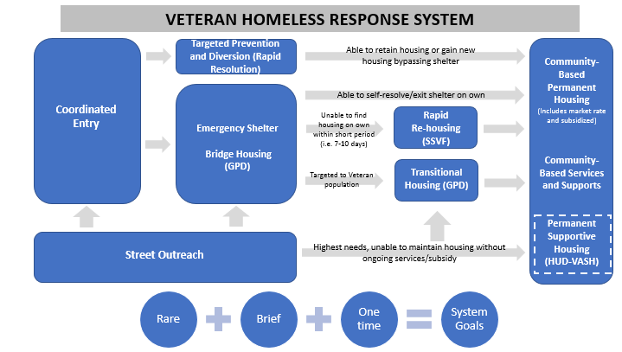
How will we measure progress?
Effectively ending veteran homelessness does not mean that no veteran will ever experience homelessness again. Rather, effectively ending homelessness means that we prevent homelessness whenever possible, and when that is not possible, the experience of homelessness is rare, brief and nonrecurring. Because each component of what it means to end homelessness is important and distinct, four performance measures will help us monitor progress on preventing and ending homelessness:
- Reduce the number of veterans who become homeless for the first time (prevention)
- Reduce the total number of veterans experiencing homelessness (rare)
- Reduce the length of time veterans experience homelessness (brief)
- Reduce the number of veterans who return to homeless (nonrecurring)
These performance measures will be monitored primarily through data from the Homeless Management Information System, a continuum-wide database used by homeless assistance providers to identify who is served and to track key outcomes and performance information. In addition, the annual Point-in-Time count (PIT count) will serve as an annual measure of progress for reducing veteran homelessness in the Iowa BoS CoC. Biennial PIT counts are required by HUD but are conducted annually by staff and volunteers across Iowa on a single night each January. While counting methods, data sources and coverage across rural Iowa continue to improve, these counts always represent a minimum estimate of the number of Iowans experiencing homelessness.
Iowa BoS CoC will verify its achievement of ending veteran homelessness when it meets the following criteria established through the United States Interagency Council on Homelessness:
1. The community took steps needed to identify all Veterans experiencing homelessness, including Veterans who were unsheltered, as well as Veterans in shelter, in Grant Per Diem programs and other VA residential programs, in other transitional housing programs, and in other temporary institutional settings.

2. There are no longer any Veterans experiencing unsheltered homelessness in the community. Some Veterans may not yet be in permanent housing, but all are now in some form of shelter (emergency shelter, treatment programs, transitional programs, other temporary institutional settings, etc...)

3. The community has the resources and a plan and timeline for providing permanent housing opportunities to all Veterans who are currently sheltered but are still experiencing homelessness. The community has identified the programs and resources that will be used to provide those housing opportunities and can provide those housing opportunities quickly and without barriers to entry, using Housing First principles and practices.

4. The community has resources, plans, and systems in place for identifying (1) Veterans that may have been missed in initial efforts to identify Veterans, (2) at-risk Veterans and (3) Veterans newly experiencing homelessness in the future.
a. The community has adequate outreach and engagement strategies in place to be confident that they can identify such Veterans.
b. The community has an adequate level of resources and the capacity to provide appropriate services to prevent homelessness for at-risk Veterans in the future.
c. The community can provide options for shelter and has identified the programs and resources that will be used to provide quick access to permanent housing opportunities for these Veterans not addressed in the initial work.

5. The community has an adequate level of resources and appropriate plans and services in place to ensure the housing stability of formerly-homeless Veterans currently in permanent housing or who enter permanent housing in the future.

Progress to date

As the coordinated efforts continue to establish an accurate by-name list for individuals experiencing homelessness across the BoS CoC, our progress is most often depicted through the annual point in time data. The most recent Iowa BoS CoC PIT data, (Figure 3.0), collected by the Institute for Community Alliances, shows an overall reduction of 36.4% since 2011 while the unsheltered numbers have remained rather consistent over the past eight years. In the past two years, although numbers have only declined slightly, the physical coverage for outreach teams on the night of the count has increased from only reporting in 57 counties to 75 counties this year, a major accomplishment in a state with a mostly rural geography.

Figure 3.0

Our Strategic Plan
Figure 4.0 below, outlines the goals, action steps, primary leadership and target dates of completion needed for success in ending Veteran Homelessness across the Iowa BoS CoC. The plan will be reassessed each quarter to note progress and make changes as needed. Progress will be reported to the Iowa BoS CoC Executive Committee, VA leadership, and state and local civic leaders engaged in the effort.

Figure 4.0
Goal | Action Steps | Responsible Group | Target Dates
Establish a sub-committee | Endorsement from Iowa Council on Homelessness and/or Iowa BoS CoC to establish sub-committee | IA Ending Veteran Homelessness group | 1-17-2020
 | Identify chairs of the Veterans Homelessness Sub-Committee | Sub-Committee | 2-1-2020
 | Get civic leadership involved- sign onto goal of ending Veteran Homelessness in cities across the state | Sub-Committee, VA, Mayors Offices | ongoing
 | Educate and train CoC and community providers on Federal Criteria & Benchmarks | Sub-Committee, USICH regional representative | ongoing
Create a master list of homeless Veterans | Request ICA to develop a Master List benchmark tracking tool within HMIS | Sub-Committee, ICA | 1-17-2020
 | Develop and refine referral process for CE access points to VA and get it adopted into IA BoS CE policies and procedures | Sub-Committee and IA BoS CE sub-committee | 2-1-2020
 | Continue to advance quality of Master List based upon HMIS specifications and community feedback | Sub-Committee | ongoing
 | Educate community partners on CE to increase participation in HMIS/CE process resulting in a more comprehensive list | Sub-Committee | ongoing
 | Assess other gaps in HMIS data and develop a plan to ensure information for all homeless Veterans who sign a consent is entered on the Master List | Sub-Committee | ongoing
Continue Weekly/bi-weekly case conferencing of Veterans as needed in areas of higher concentrations of Homeless Veterans | Establish regular meeting times for case conferencing | Sub-Committee | 12-1-2019
 | Evaluate success of conferencing process at monthly task force meetings | Sub-Committee | ongoing
Swiftly move veterans into permanent housing | Monitor number of Veterans housed every month with the goal of housing more Veterans than enter homelessness each month | Sub-Committee | ongoing
 | Analyze existing permanent housing resources against anticipated inflow to see if there are any resource gaps | Sub-Committee | ongoing
 | Identify additional sources of permanent housing  options | Sub-Committee | ongoing
 | End chronic Veteran homelessness, ensure every chronically homeless Veteran who chooses not to go to PH is offered PH first | Sub-Committee, community partners | ongoing
Identify and prevent at-risk veterans who  are in danger of losing their homes from falling into homelessness | Implement Diversion and Prevention policies and procedures (Rapid Resolution) across the IA BoS CoC | SSVF grantees, Sub-Committee and CE sub-committee | 3-1-2020
Complete application to be certified as Ending Veteran’s Homelessness | Maintain 90-day status on ending veteran’s homelessness as prerequisite to apply | CoC | ongoing
 | Complete the application to USICH | Sub-Committee, CoC, VA | 12-1-2020
Strengthen Community Partnerships to Sustain and continue to improve Strategies | Work with VA to strengthen partnership with community providers | Sub-Committee, VA | ongoing
 | Work with PHAs across the state to build/strengthen partnerships | Sub-Committee | ongoing
 | Advocate for SSVF to span the state- recruit additional community partners to administer SSVF funds and/or assist current SSVF providers to expand their coverage area | Sub-Committee | ongoing
 | Develop Landlord Recruitment and Education Programs | Sub-Committee, CoC, VA | 6-1-2020
 | Engage and plan with rural partners in finding additional options for rural homeless veterans | Sub-Committee, CoC | ongoing
 | Implement training and technical assistance on best practices in serving Veterans | Sub-Committee, VA | 1-1-2021

Stakeholders and Strategic Partners in Ending Veteran Homelessness in the Iowa BoS CoC
Iowa Council on Homelessness  (the body responsible for Iowa’s BoS planning) | - Provide ongoing oversight of performance measurement and oversee the by-name list  - Establish policies, goals and procedures for the CoC  - Oversee the BoS CoC funding process  - Provide forum for interagency collaboration  - Coordinate statewide collaboration with Polk County, Woodbury and MACCH
Coordinated Entry Committee & Regions  - CE Committee  - 12 + CSRs | - Create protocol and call system for diversion/assessment of all presenting as homeless  - Oversee CE process and ensure accurate identification of and referral process for vets  - Lead local Point in Time Counts  - Work with SSVF and VSOs to find solutions for veterans ineligible for VA programs  - Engage other local vet services in coordinated entry  - Organize and participate in regional stand downs  - Support food/clothing drives for veterans
Iowa Department of Veterans Affairs | - Advocate for veterans as part of ICH  - Coordinate communication of state- and federal-level VA housing issues with CSRs
Veteran Service Officers | - Actively participate in CSRs  - Assist vets in obtaining lost DD214/service documents  - Assist vets in appealing discharge/disability status that may result in increased eligibility  - Refer vets not eligible for VA programs to CE  - Provide emergency assistance for Veterans, where funds exist, as appropriate
SSVF Grantees  - Primary Health Care  - FAVA  - HACAP  - Humility Homes and Services, Inc. | - Outreach and identify homeless veterans  - Ensure access to emergency beds  - Act as a system navigator for veterans  - Assess eligibility for SSVF program  - Refer to VAMC FOR VA eligibility assessment  - Connect with permanent housing  - Actively participate in CSRs
VA Health Care: Medical Centers & Clinics | - Assess veterans for VA eligibility  - Work with each CSR to utilize the by-name list in awarding HUD-VASH vouchers  - Connect eligible vets to Grant Per Diem programs  - Coordinate VA outreach activities in each CSR  - Participate in each CSR’s CE process and utilize the by-name list to prioritize resources
Grant Per Diem Programs  - Humility Homes and Services, Inc.  - Shelter House  - Willis Dady | - Actively participate in CSRs  - Provide housing for veterans in appropriate assessment score range
CoC and ESG Grantees | - Connect veterans not eligible for HUD-VASH or SSVF services to the regions’ CE process to access housing  - Provide permanent housing resources for veterans who chose to not access SSVF services and/or are ineligible for VA programs
Public Housing Authorities | - Administer HUD-VASH vouchers, where allocated  - Assist with porting HUD-VASH vouchers as needed  - Establish preferences for homeless veterans for available vouchers and/or units  - Assist with permanent housing providers in developing Move On® programs designed to increase exits to permanent housing and capacity to serve more households
Non-federally funded Services | - Provide temporary shelter for veterans  - Provide food, clothing to veterans
Other Vet Organizations  - Vet Centers  - VFWs/Legions | - Participate in stand downs  - Fundraising for homeless veterans  - Direct homeless vets to service access points

