Iowa Regional CoC Governance Model
Transition Team Recommendations

Proposed Motion: Revisions to Iowa Balance of State CoC Governance Structure
The recommendations of the Iowa Balance of State Continuum of Care (CoC) Transition Team are to:
- Adopt the recommendations of the Transition Team (see below for additional detail) as the overall vision for revising the CoC’s governance structure;
- Empower the CoC Transition Team to lead an open application process for nominating members to an Interim CoC Board, pending confirmation by the Iowa Council on Homelessness (ICH);
- Empower the Interim CoC Board to assume responsibilities as the CoC Board for the Iowa Balance of State CoC from the Iowa Council on Homelessness (ICH), pending the selection of a permanent CoC Board, upon ICH confirmation of Interim Board membership; and
- Instruct the Interim CoC Board to begin the process of nominating members of a permanent CoC Board and otherwise implement the recommended governance structure, as appropriate.

Overview of Transition Team Recommendations
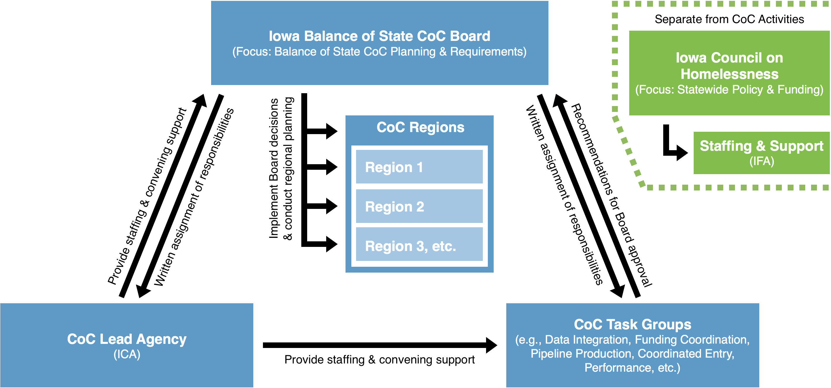
The Iowa Balance of State Continuum of Care (CoC) Transition Team submits the following revisions to the CoC’s governance structure to improve the functionality of both the CoC and Iowa Council on Homelessness (ICH), in accordance with the organizational chart above:
- Remove CoC responsibilities from the Iowa Council on Homelessness, enabling ICH to focus on its statutory responsibilities for statewide policy and planning;
- Establish a separate CoC Board to manage the Balance of State CoC;
- Adopt a regional CoC governance model to better support planning and implementation of best practices for preventing and ending homelessness throughout the geographic extent of the Continuum.

CoC Board
The CoC Board will be responsible for:
- Operating the CoC, including: setting Continuum-wide priorities; assigning written responsibilities to the CoC Regions, CoC Task Groups, and CoC Lead Agency and providing oversight to their efforts; drawing boundaries between CoC Regions; and approving recommendations generated by the CoC
- Designating and operating an HMIS by setting priorities for and overseeing the work of the HMIS Lead/administrator; and
- Managing the annual CoC competition, including preparing the CoC application for submission to HUD
It will consist of 20 members, representing geographic balance and including designated seats for: government staff/officials (4 seats); subpopulation representatives (4); health and/or disability services (1); mental health (1); substance abuse (1); education (1); criminal justice (1); other funders (2); faith-based community (1); homeless or formerly homeless individual (1); and others (3).

CoC Regions
The CoC Regions will form the backbone of the Continuum’s response to homelessness. Each Region will essentially function as a CoC-in-miniature within their geographic area, responsible for the following duties:
- Regional planning of homeless housing and services and implementation of both regional and CoC Board decisions, including operation of the coordinated entry system;
- Advocating for regional interests to the CoC Board and providing a single point of contact for local organizations and/or jurisdictions seeking to address homelessness within their geographic area; and
- Other duties as assigned by the CoC Board.
CoC Regions will initially be based upon the existing Coordinated Entry Regions.

CoC Lead Agency
The Institute for Community Alliances (ICA) will serve as the CoC Lead Agency and primarily responsible for providing professional support to the CoC Board and the CoC, as directed by the CoC Board through a written assignment of responsibilities. These responsibilities will include:
- Providing staffing and convening support to the CoC Board, CoC Task Groups, and CoC Regions;
- Leading communication efforts, including both external and internal communications;
- Managing the day-to-day implementation of the annual CoC competition and HUD application processes;
- Other duties as assigned by the CoC Board.

CoC Task Groups
CoC Task Groups are permanent or ad hoc committees to coordinate oversight of discrete activities and provide recommendations to the CoC Board for approval. CoC Task Groups should be created by the CoC Board per a written process contained in the Continuum’s governance charter. Task Group responsibilities and subject matter will be assigned by the CoC Board per a written assignment of responsibilities.
CoC Task Group membership should be based upon experience and familiarity with the relevant subject matter, as determined by the CoC Board. Individual Task Groups should strive incorporate regional diversity into their membership structure to increase buy-in across the Continuum.

Iowa Council of Homelessness
Under this plan, the Iowa Council on Homelessness will be fully separated from CoC activities and serve primarily to advance its statutory purpose of coordinating statewide policy and funding for preventing and ending homelessness. The Iowa Finance Authority (IFA) will continue to provide professional staffing and support to the Council. To ensure that the Iowa Council on Homelessness maintains solid connections to the individual CoCs in the state, we recommend that ICH membership include a representative from each Iowa CoC.

