Iowa Regional CoC Governance Model
Transition Team Recommendations

Overview
The Iowa Balance of State Continuum of Care (CoC) charged a Transition Team with considering various refinements of the existing CoC governance structure (see Attachment B). In this document, the Transition Team outlines its recommendations for a revised governance structure to improve the functionality and effectiveness of both the CoC and Iowa Council on Homelessness (ICH), entailing three major changes:
- Remove CoC responsibilities from the Iowa Council on Homelessness, enabling ICH to focus on statewide policy and planning;
- Create of a separate CoC Board to manage the Balance of State CoC; and
- Adopt a regional CoC governance model to better support planning and implementation of best practices for preventing and ending homelessness throughout the geographic extent of the Continuum.
The organizational chart of the proposed governance structure included below provides an overview of the recommended revisions. Details regarding the proposed role, responsibilities, and composition of each entity within the organizational chart are highlighted in the following pages.

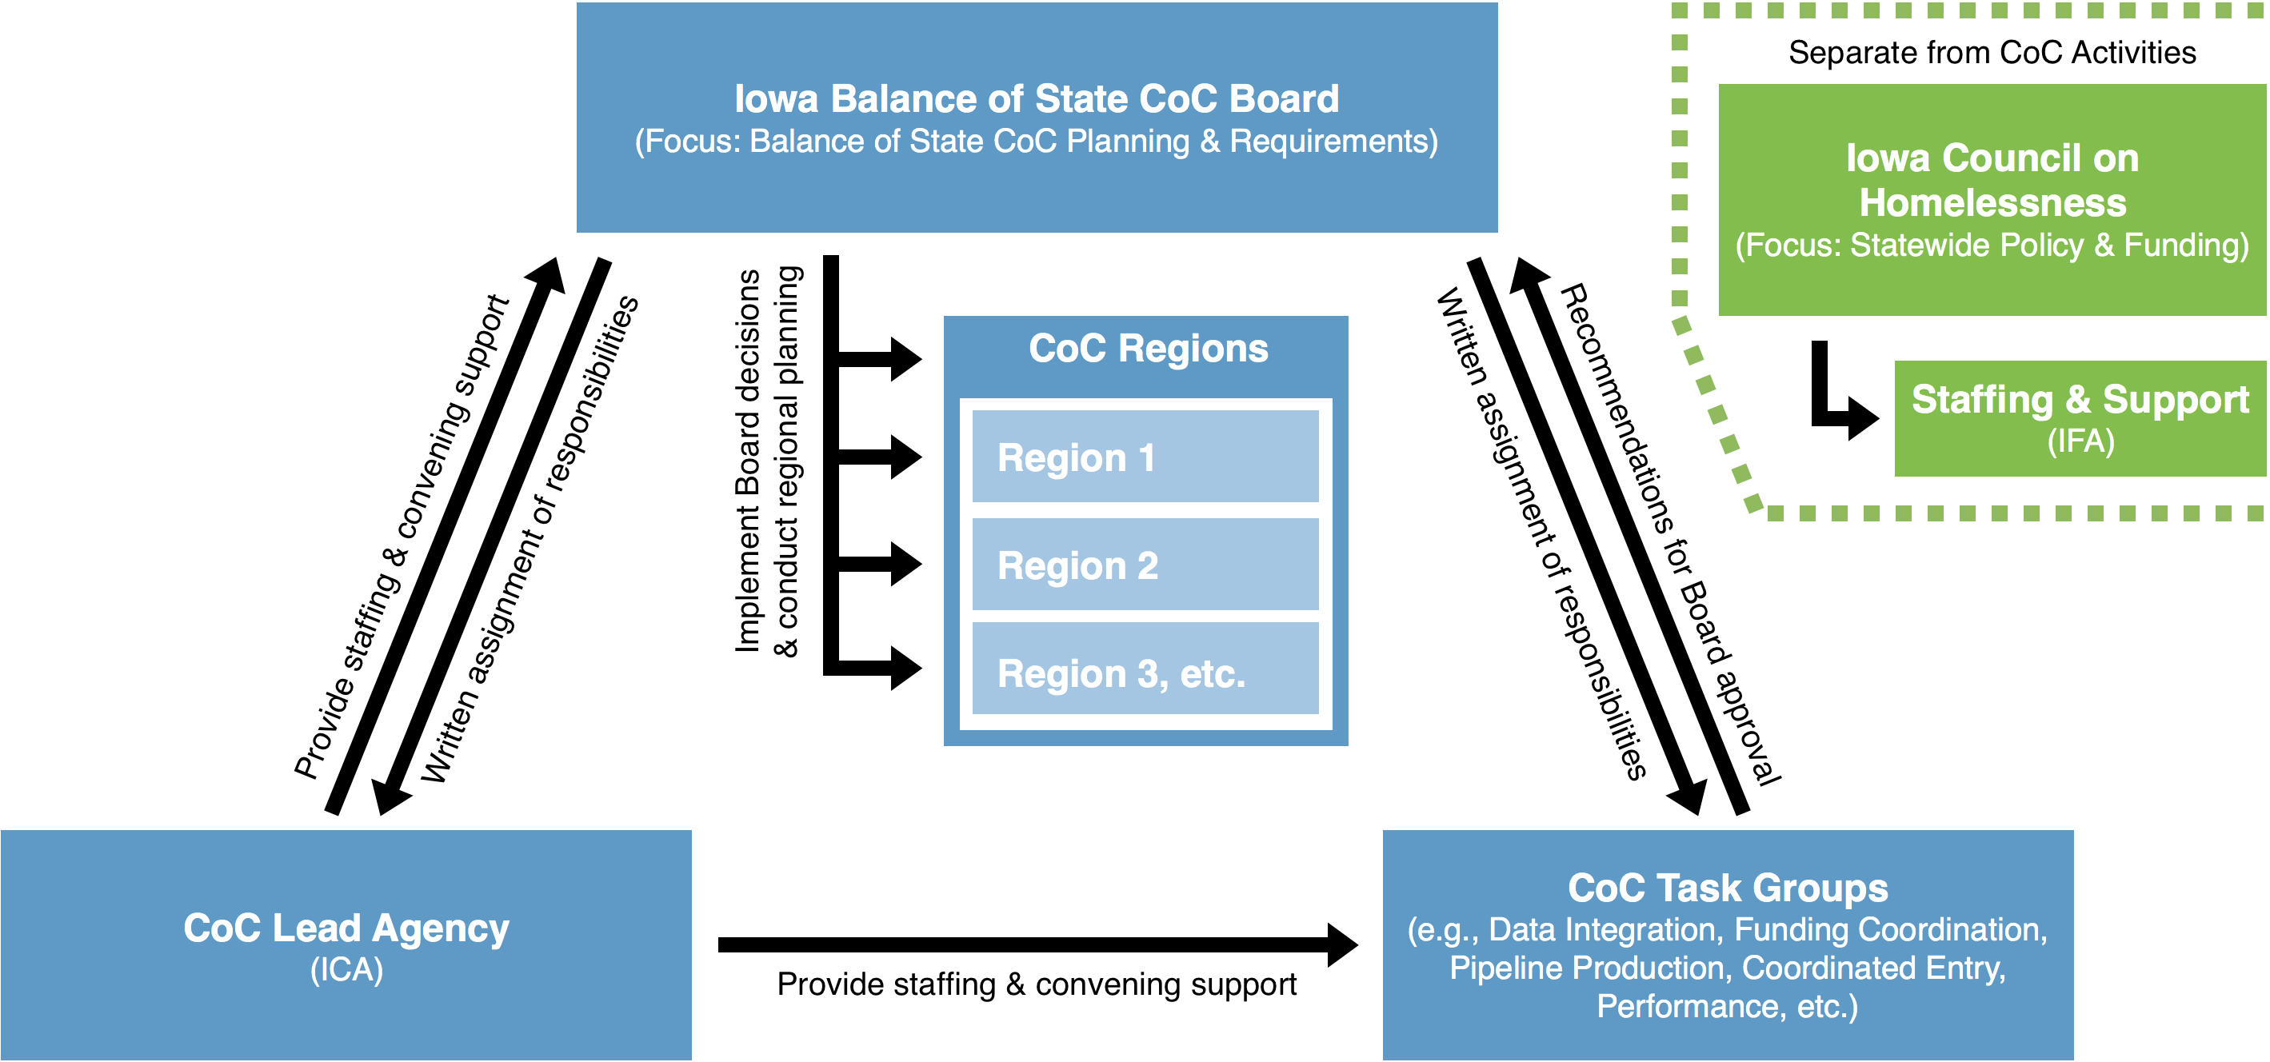

Iowa Balance of State CoC Board
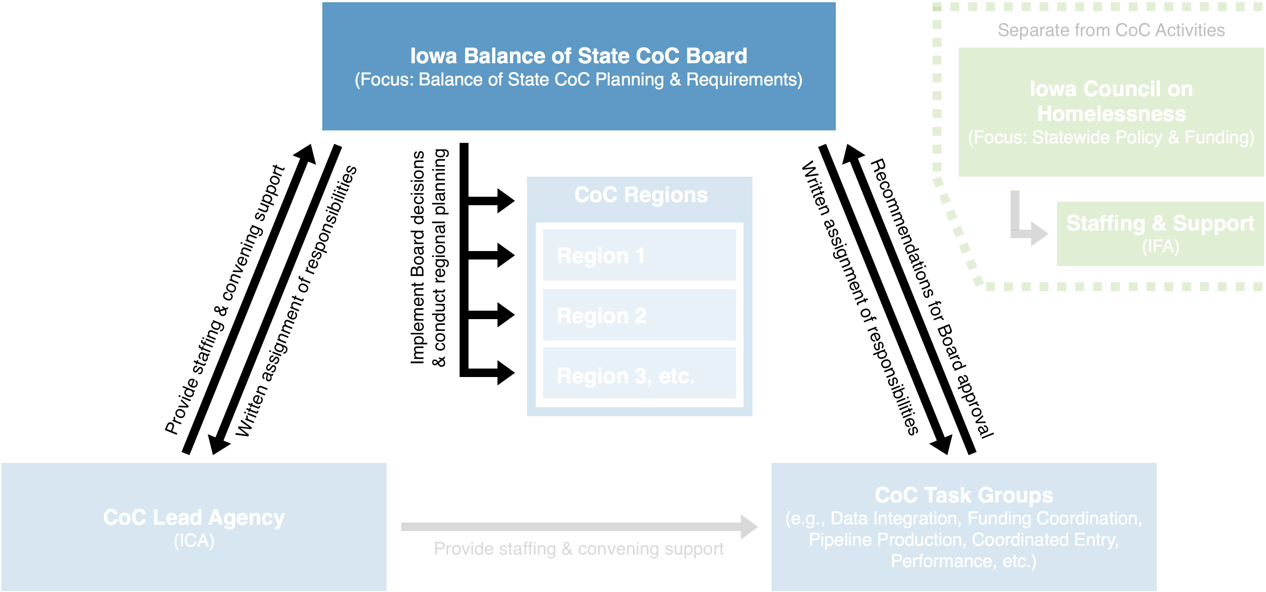
The Iowa Balance of State CoC Board will assume primary responsibility for the full range of Balance of State CoC activities currently overseen by the Iowa Council on Homelessness. The CoC Board will provide high-level oversight and direction-setting to the overall Continuum, while handling three primary responsibilities:
- Operate the CoC, including:
  - Setting Continuum-wide priorities;
  - Assigning written responsibilities to the CoC Regions, CoC Task Groups, and CoC Lead Agency and providing oversight of their efforts
  - Drawing boundaries between CoC Regions; and
  - Approving recommendations generated by CoC Task Groups.
- Designate and operate an HMIS by setting priorities for and overseeing the work of the HMIS Lead/administrator.
- Manage the annual CoC competition, including preparing the CoC application for submission to HUD.
Other day-to-day responsibilities will be delegated to the CoC Regions, CoC Task Groups, and CoC Lead Agency, as appropriate (see the following sections for more details regarding the role and responsibilities of each of these entities).
Next Step: Conduct Strategic Planning
In order to effectively operate the CoC, the CoC Board is responsible for developing and implementing a strategic plan that sets Continuum-wide priorities and establishes long-term goals related to those priorities. Then, having developed a strategic plan for preventing and ending homelessness within the CoC, the CoC should conduct annual planning designed to achieve the long-term goals outlined in the strategic plan:
- Identify appropriate tasks and sub-tasks that, over time, are necessary in order to accomplish the CoC’s priorities and goals;
- Allocate responsibility for implementing those actions to appropriate entities, such as the CoC Task Groups, CoC Lead Agency, HMIS Lead Agency, etc.; and
- Conduct oversight to ensure implementation of the tasks and measure progress towards long-term goals.

Background: CoC Board Membership
Board members must be selected using a written process adopted by the CoC, contained in the CoC’s Governance Charter, and reviewed, updated, and approved by the Continuum at least once every 5 years. The Board must be representative of the relevant stakeholders involved in preventing and ending homelessness within the CoC and include at least one homeless or formerly homeless individual. Given the broad geographic area of the Balance of State CoC, special attention should be paid to ensure that Board membership includes stakeholders from across Iowa. The CoC Board should consist of representatives from some combination of the following:
Seat(s) | Representative(s)
Required Representatives:
Regions | - Regional/constituency representatives
Lived Experience | - Homeless or formerly homeless individuals
Optional Stakeholder Representatives:
Government | - Local government staff/officials, CDBG/HOME/ESG entitlement jurisdictions, Public Housing Authorities (PHAs), League of Cities, Parks and Recreation/Department of Natural Resources; etc.
Health | - Hospitals, EMS/crisis response teams, etc.
Mental health | - Mental health service organizations, advocates, etc.
Substance abuse | - Substance abuse service delivery organizations, advocates, etc.
Education | - School administrators, homeless liaisons, etc.
Criminal justice | - Law enforcement, local jails, etc.
Disability services | - Disability service organizations, advocates, etc.
Victim services | - CoC-funded/non-CoC-funded victim service providers, advocates, agencies that serve survivors of human trafficking, etc.
Veterans | - VA, veteran service organizations, advocates, etc.
LGBT | - LGBT service organizations, advocates, etc.
Youth | - CoC-funded/non-CoC-funded youth homeless organizations, advocates, etc.
Other | - Street outreach  - Housing developers  - Faith-based community  - Farmers’ associations  - Rural electric cooperatives and/or utility companies  - Other homeless subpopulation advocates
The Continuum must establish a code of conduct and recusal process for the Board, its officers, and any person acting on behalf of the Board. This is necessary because Board members are subject to a strong conflict of interest requirement: No Continuum of Care Board member may participate in or influence discussions or resulting decisions concerning the award of a grant or other financial benefits to the organization that the member represents.
To ensure cohesion and promote efficiency, the size of the Iowa Balance of State CoC Board should be set at a manageable level, consisting of no more than 15-20 voting members. Note that, in most cases, Board members may fill more than one representative role. For example, each regional representative may occupy two roles on the Board (i.e., one person may simultaneously be the representative for a CoC Region and a representative for youth homeless organizations).

Proposal: CoC Board Membership
Considering the above, the Transition Team recommends that the revised CoC Board consist of the following membership, reflecting the variety of interested stakeholders active within the Continuum:
Dedicated Seats | Representative(s)
Government (4 Seats)  Examples:  - Local government staff/officials  - CDBG/HOME/ESG entitlement jurisdictions  - Public Housing Authorities  - League of Cities  - Parks and Recreation or Department of Natural Resources, etc. | 1.  2.  3.  4.
Subpopulations (4 Seats)  One seat for each of the following subpopulations:  - Veterans (incl. CoC-funded/non-CoC-funded veteran homeless organizations, advocates, VA, etc.)  - Youth (incl. CoC-funded/non-CoC-funded youth homeless organizations, advocates, etc.)  - Survivors of Domestic Violence (incl. CoC-funded/non-CoC-funded victim service providers, advocates, or agencies that serve survivors of human trafficking, etc.)  - LGBT (incl. LGBT service organizations or advocates, etc.) | 5.  6.  7.  8.
Health and/or Disability Services (1 Seat)  Examples:  - Hospitals or hospital systems  - EMS/crisis response teams, etc.  - Disability service organizations  - Disability advocates, etc. | 9.
Mental Health (1 Seat)  Examples:  - Mental health service organizations  - Mental illness advocates | 10.
Substance Abuse (1 Seat)  Examples:  - Substance abuse service delivery organizations  - Substance abuse advocates, etc. | 11.
Education (1 Seat)  Examples:  - Universities  - School administrators  - Homeless liaisons, etc. | 12.
Criminal Justice (1 Seat)  Examples:  - Law enforcement  - Local jails, etc. | 13.
Other Funders (2 Seats)  Examples:  - Government agencies  - Non-profit foundations  - Charities, etc. | 14.  15.
Faith-Based Community (1 Seat)  Examples:  - Churches  - Rescue Missions, etc. | 16.
Homeless or Formerly Homeless Individual (1 Seat)  Note: Each CoC is required to maintain at least one seat for a homeless or formerly homeless individual on their CoC Board. | 17.
Other (3 Seats)  Note: To ensure maximum representation, the three “Other” seats should be reserved for interests not represented, in any manner, by the other CoC Board members, such as:  - Housing and service providers (incl. emergency shelter, transitional housing, permanent housing, etc.)  - Other partners (incl. utility cooperatives, etc.) | 18.  19.  20.

Proposal: CoC Board Meetings
The Iowa Balance of State CoC Board should hold monthly meetings to ensure that it meets its responsibilities. To promote cohesion, the Continuum should expect that Board members attend in-person, if possible, with optional remote access for those who are unable to do so. This may necessitate identifying appropriate (potentially rotating) meeting site(s) and obtaining a web-based videoconferencing service.

CoC Regions
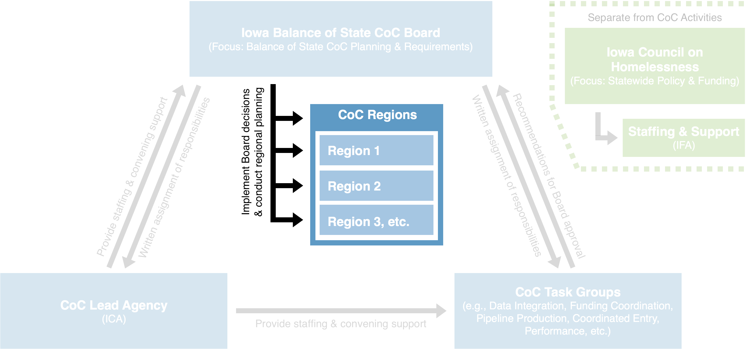
The CoC Regions will form the backbone of the Continuum’s response to homelessness. Each Region will essentially function as a CoC-in-miniature within their geographic area, responsible for the following duties:
- Regional planning of homeless housing and services and implementation of both regional and CoC Board decisions, including operation of the coordinated entry system;
- Advocating for regional interests to the CoC Board and providing a single point of contact for local organizations and/or jurisdictions seeking to address homelessness within their geographic area; and
- Other duties as assigned by the CoC Board.
In other words, the individual CoC Regions will ultimately be responsible for planning and implementing appropriate measures to prevent and end homelessness within their geographic area, subject to the coordination of the CoC Board to ensure consistency across the state, where appropriate. Wherever possible, the CoC Board and Lead Agency should align their work with these Regions to maximize the implementation of best practices across the Continuum.
Each Region should be separately managed by a representative entity or body (see CoC Board section for more information on representativeness) that is responsible to both the Iowa Balance of State CoC Board and local stakeholders. Generally, CoC Regions should share certain defining characteristics that will enhance their ability to serve as functional components of the Continuum’s response to homelessness, including:
- Geographic contiguity and/or compactness (i.e., whether the Region(s) are sufficiently interlinked such that they’re able to function as a single entity for the purposes of planning and implementing homeless housing and services within their area);
- Commonality of interests between the communities forming a single Region (i.e., whether the Region(s) share sufficient interests such that they’re able to dedicate their efforts in a coordinated fashion); and
- Sufficient resources and/or stakeholders to ensure that the Region can meet all its responsibilities (i.e., whether the Region(s) are able to undertake the duties and responsibilities assigned to them by the CoC Board).

Proposal: Utilize Coordinated Entry Regions as the Initial Basis of CoC Regions

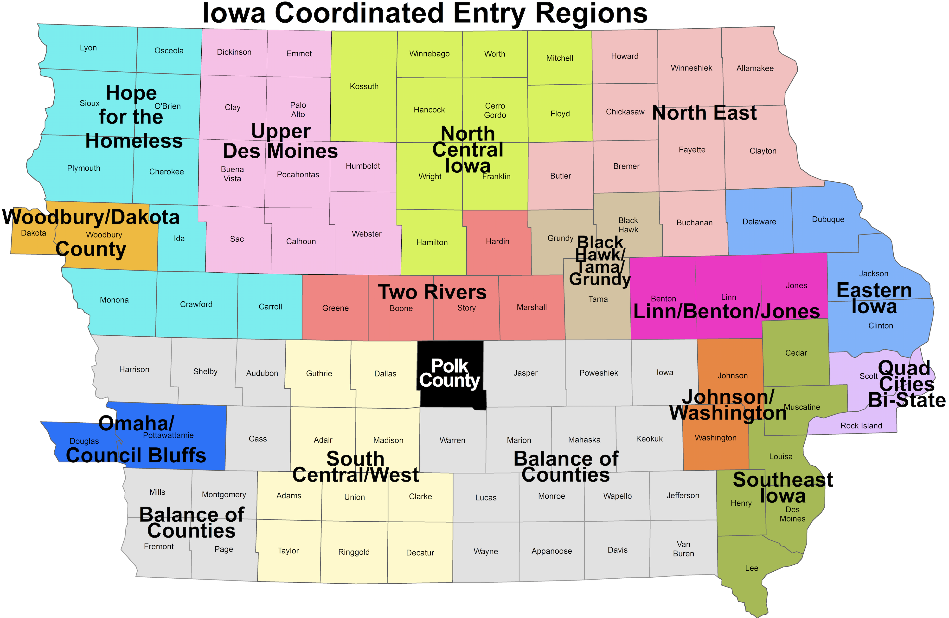The Transition Team recommends that the current Coordinated Entry Regions serve as the (initial) basis for the CoC Regions that will assume the tasks outlined in the previous section. While alternative regional alignments were considered by the Transition Team, their conclusion was that the existing Coordinated Entry Regions had several advantages over proposed alternatives, including:
- Compliance with the three prerequisites identified in the prior section (i.e., geographic contiguity and/or compactness, commonality of interests, and sufficiency of resources and/or stakeholders); and
- Ease of implementation, given their pre-existing status.
While the Coordinated Entry Regions should serve as the initial basis for the division of the entire Continuum into CoC Regions, in order to meet CoC requirements, the CoC Board should be empowered to consolidate or break apart certain Regions, with or without the consent of the areas in question, if doing so would improve geographic contiguity or compactness, commonality of interests, and/or improve the capacity of the Region.
Next Step: Address the Balance of Counties Regions
As an outlier among the existing Coordinated Entry Regions, the CoC Board should develop a plan to address the Balance of Counties Region and ensure that it is able to function as a full CoC Region in accordance with the role, responsibilities, and other attributes defining the CoC Regions in this proposal. This could entail consolidating portions of the Balance of Counties Region to other Regions, breaking the Balance of Counties Region into smaller Regions, or another alternative. Extensive capacity building will likely be required for this Region.

Proposal: Incorporate Regional Capacity Building
Under this plan, the CoC Regions will assume additional responsibilities. It is expected that the Coordinated Entry Regions, as currently constituted, may not have the capacity to adequately address each of these responsibilities. After confirming Regional geographic boundaries per the metrics discussed above, the CoC Board should work with the CoC Lead Agency and the Regions themselves to identify and provide additional capacity building where necessary (e.g., technical assistance, trainings, materials, etc.).
Next Step: Determine Capacity Building Needs
Once the Regions are established, the CoC Board and CoC Lead Agency should survey the Regions to determine capacity building needs. The Board should then direct the CoC Lead Agency to provide technical assistance, training, and other support necessary to ensure that each Region is able to perform its intended role and responsibilities.

CoC Lead Agency
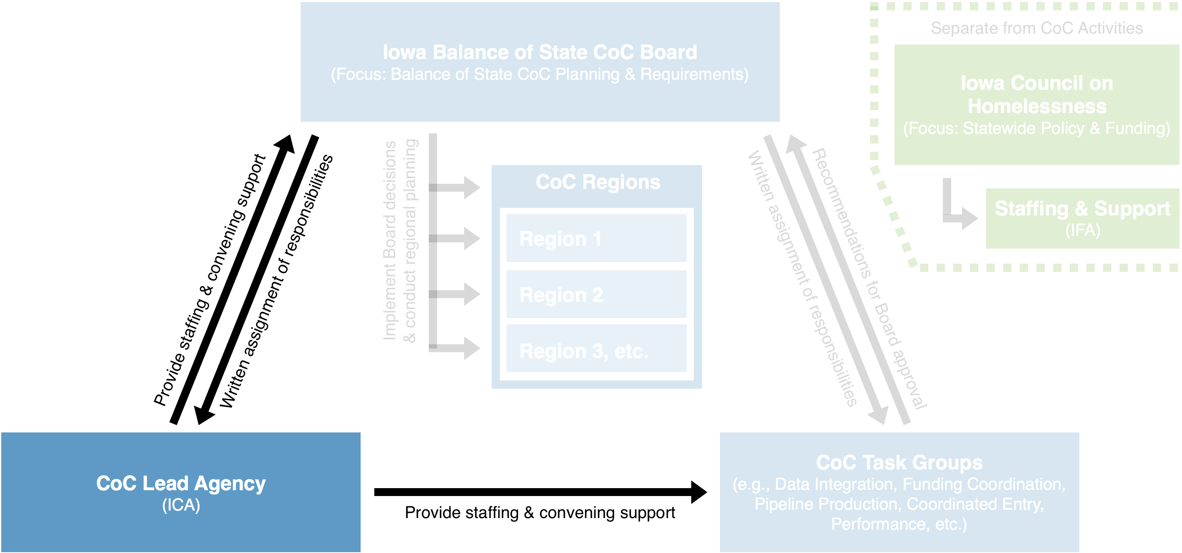
In addition to serving as the HMIS Lead for the Iowa Balance of State CoC, the Institute for Community Alliances (ICA), a non-profit organization based in Des Moines, will also serve as the CoC Lead Agency. As a CoC Lead Agency, ICA will be primarily responsible for providing professional support to the CoC Board and the CoC, as directed by the CoC Board through a written assignment of responsibilities. These responsibilities will include:
- Providing staffing and convening support to the CoC Board, CoC Task Groups, and CoC Regions, including: pre-meeting production of agendas and other materials, as appropriate; scheduling and arranging meeting times and locations; producing minutes and documenting decisions; providing expertise and managing day-to-day operations between Board meetings, etc.;
- Leading communication efforts, including both external (serving as the Continuum’s voice within the broader community) and internal communications (ensuring that decisions made by the CoC Board are disseminated to CoC stakeholders, CoC Task Groups, and CoC Regions, as appropriate);
- Managing the day-to-day implementation of the annual CoC competition and HUD application processes;
- Other duties as assigned by the CoC Board.

CoC Task Groups
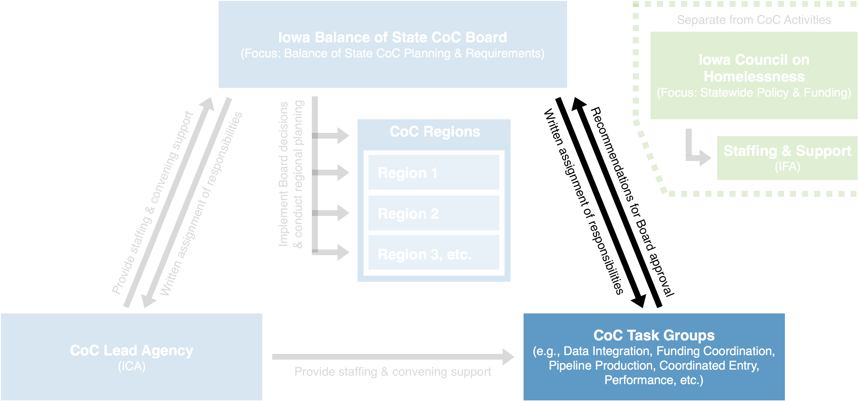
CoC Task Groups are either permanent or ad hoc committees to coordinate oversight of discrete activities and provide recommendations to the CoC Board for approval. CoC Task Groups should be created by the CoC Board per a written process contained in the Continuum’s governance charter. Task Group responsibilities and subject matter will be assigned by the CoC Board per a written assignment of responsibilities and may cover topics such as:
- Membership and Nominations;
- Governance and Planning;
- Data Integration;
- Funding Coordination;
- Housing Production;
- Coordinated Entry;
- Performance; and
- Other topics assigned by the CoC Board.
CoC Task Group membership should be based upon experience and familiarity with the relevant subject matter, as determined by the CoC Board. It is advisable – though not essential, given regional representation on the CoC Board – that individual Task Groups incorporate regional diversity into their membership structure to increase buy-in across the Continuum.
Task Groups should not make final decisions, except where specifically delegated authority to do so by the CoC Board, and should otherwise submit recommendations to the CoC Board for approval prior to implementation.
Next Step: Identify Appropriate CoC Task Groups
As part of the Continuum’s overall strategic planning process, the CoC should an appropriate range of Task Groups to conduct CoC business. This will entail, at a minimum, determining whether:
- The range of subjects covered by existing CoC Task Groups is sufficient to address the range of day-to-day operations necessary to perform CoC activities and meet the long-term goals of the Continuum contained in the strategic plan (i.e., should the portfolios of the existing CoC Task Groups be changed, should existing Task Groups be eliminated, or should new Task Groups be created);
- Existing CoC Task Groups should fall within the organization structure of the CoC (where they are dedicated to CoC-specific activities) or remain under the ICH (where they are dedicated to statewide issues and activities); and
- Existing CoC Task Groups are adequately performing their role and responsibilities (Task Groups that are functioning effectively, such as the Coordinated Entry Task Group, should not be altered).

Iowa Council on Homelessness
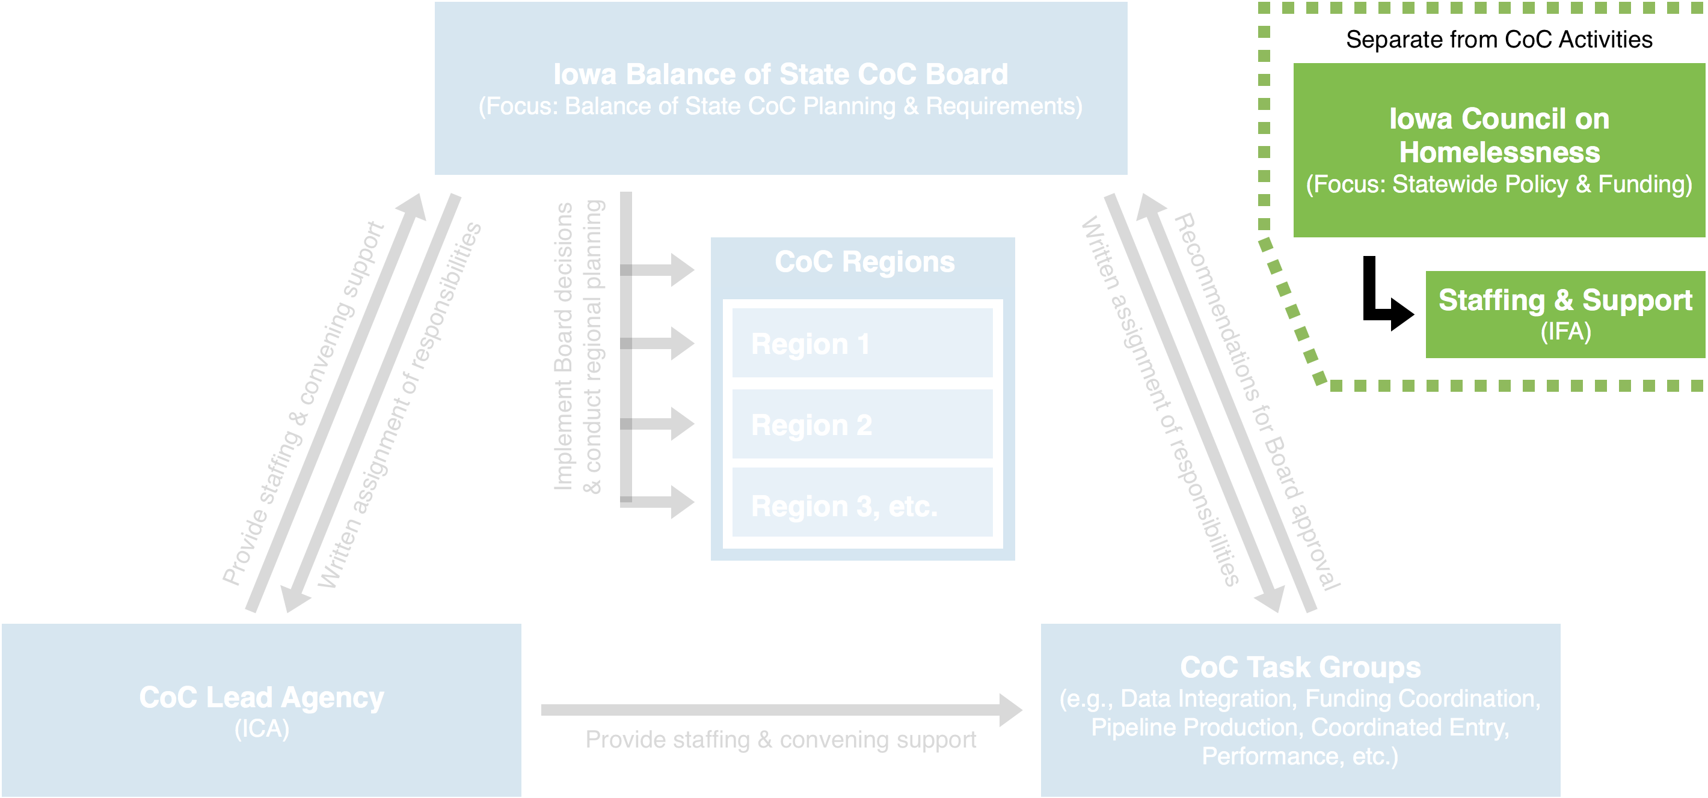
Under this plan, the Iowa Council on Homelessness will be fully separated from CoC activities and serve primarily to advance its statutory purpose of coordinating statewide policy and funding for preventing and ending homelessness. The Iowa Finance Authority (IFA) will continue to provide professional staffing and support to the Council. To ensure that the Iowa Council on Homelessness maintains solid connections to the individual CoCs in the state, we recommend that ICH membership include a representative from each Iowa CoC.
These changes will better allow ICH to focus on the tasks and duties outlined in the Iowa Statute and Administrative Code:
- Develop a process for evaluating state policies, programs, statutes, and rules to determine whether any state policies, programs, statutes, or rules should be revised to help prevent and alleviate homelessness.
- Evaluate whether state agency resources could be more efficiently coordinated with other state agencies to prevent and alleviate homelessness.
- Work to develop a coordinated and seamless service delivery system to prevent and alleviate homelessness.
- Use existing resources to identify and prioritize efforts to prevent persons from becoming homeless and to eliminate factors that keep people homeless.
- Identify and use federal and other funding opportunities to address and reduce homelessness within the state.
- Work to identify causes and effects of homelessness and increase awareness among policymakers and the general public.
- Advise the Governor’s office, the Iowa Finance Authority, state agencies, and private organizations on strategies to prevent and eliminate homelessness.
- Make annual recommendations to the Governor regarding matters which impact homelessness on or before September 15.
- Prepare and file with the Governor and the General Assembly on or before the first day of December in each odd-numbered year a report on homelessness in Iowa.
- Assist in the completion of the state’s Continuum of Care application to the U.S. Department of Housing and Urban Development.
Note that, under this revised CoC governance structure, the CoC Board will assume primary responsibility for the last task listed above (completion of the Balance of State CoC’s Continuum of Care application) with ICH taking on an advisory role only.
Next Step: Conduct Strategic Planning
As a result of these changes to the Iowa Balance of State Continuum of Care, the ICH will need to rethink whether and how to carry out its responsibilities. This will likely require a strategic planning process to figure out whether the existing structure and operational practices of the ICH are sufficient to address the full range of statewide policy and planning for which the ICH is responsible.

Timeline and Next Steps
Immediate Next Steps:
- Iowa Council on Homelessness: Vote to approve the initial recommendations generated by the Transition Team and contained in this document. Task the Transition Team with soliciting and identifying an appropriate Interim CoC Board to temporarily assume CoC Board duties, elaborate upon these recommendations, and generate a process for selecting a permanent CoC Board.
- Transition Team: Develop and distribute an application process (see Attachment A) soliciting members to serve on the Interim CoC Board. The application should be distributed to CoC membership no later than January 28, 2020 – earlier if possible – with responses due by Monday, February 3rd. Upon consideration of applications received, the Transition Team should recommend a proposed Interim CoC Board to the Iowa Council on Homelessness.
- Iowa Council on Homelessness: Approve the Transition Team’s proposed Interim CoC Board via an email vote. The Interim CoC Board will immediately assume the responsibilities of the CoC Board for the Iowa Balance of State CoC.
Other Next Steps (Quarter 1):
- Notify HUD and e-snaps of the newly named/formed CoC Board.
- Interim CoC Board meets and develops a plan for identifying membership on the permanent CoC Board per the outline contained in this document.
- Interim CoC Board develops an RFP/RFQ to assist IFA with the current role of CoC Lead Agency, laying out the roles and responsibilities that could be assumed following the official transfer.
- Interim CoC Board begins coordinating with CoC Regions, detailing their roles and responsibilities under this new model, identifying points of contact, developing expectations, etc.
Other Next Steps (Quarter 2):
- Interim CoC Board and CoC membership approves membership on permanent CoC Board. CoC Board duties immediately transfer from the Interim CoC Board to the permanent CoC Board.
- Iowa Council on Homelessness meets for the first time with the role, responsibilities, and purposes outlined in this document.
- CoC Board begins the NOFA application process, following HUD’s guide to update the CoC Board and CoC Lead Agency designations.
Other Next Steps (Quarter 4):
- New CoC Lead Agency officially assumes duties.

Attachment A: Draft Membership Application for Interim CoC Board
IOWA BALANCE OF STATE INTERIM COC BOARD
MEMBERSHIP APPLICATION
Applicant Name:
Name of Agency/Organization (if applicable):
E-mail:
Telephone:
Address:
City: | State: |  | Zip Code:
Which designated seat are you interested in filling? |  | ☐ Government  ☐ Subpopulations (detail: _________________________)  ☐ Health and Disability Services  ☐ Mental Health  ☐ Substance Abuse  ☐ Education  ☐ Criminal Justice  ☐ Other Funders  ☐ Faith Based  ☐ Homeless or Formally Homeless  ☐ Other (detail: _________________________________)
Do you work for or are you affiliated with an agency/organization that currently receives CoC funding within the Iowa Balance of State CoC?
☐Yes ☐No ☐Unknown
If yes, indicate the nature of your relationship with the agency/organization:
☐Board member ☐Contractor ☐Employee ☐Volunteer ☐Other _________________
If elected, are you willing to participate in mandatory training for the entire CoC Board?
☐Yes ☐No
EXPLANATION OF QUALIFICATIONS FOR THE INTERIM COC BOARD
Briefly describe the experience or expertise that qualifies you to represent the specific seat identified:

What are characteristics you possess that make you a strong candidate for the Board?

What else would you like the Iowa Balance of State CoC Membership to know about you?

NEXT STEPS
- Please submit this completed application, along with a resume and short biography (no longer than 450 words) to Patrick Wigmore (patrick@homebaseccc.org) by February 3, 2020
- Your application will be reviewed and considered by the Transition Team charged with developing a new Interim CoC Board.

Attachment B: Background and History
In mid-2018, the Iowa Balance of State Continuum of Care (CoC) requested technical assistance (TA) from the Department of Housing and Urban Development (HUD) related to the existing decision-making processes and governance structures of the CoC. Members of the CoC were particularly concerned with how the Balance of State CoC was interwoven with the Iowa Council on Homelessness (ICH). The purpose of the TA was to determine whether a governance restructuring could improve the functionality of both entities and facilitate a more effective implementation of best practices for preventing and ending homelessness. Specifically, the TA focused on whether (1) the ICH should continue to act as the CoC’s primary decision-making body or (2) a different and/or new entity should assume responsibility for that role.
Through numerous interviews and meetings with stakeholders throughout the course of the TA, several key challenges with the existing governance structure were identified:
- The current governance structure results in an overemphasis on Balance of State CoC-related activities at ICH meetings. While the Balance of State CoC covers the geographic majority of the state, it does not include three of the more populous cities – Des Moines, Sioux City and Council Bluffs – and their surrounding areas. In addition, CoC-related work is often time-intensive and can require technical knowledge of federal regulations related to HUD’s Continuum of Care Program. A disproportionate amount of ICH’s time was thus spent on issues related to the Balance of State CoC and that related funding stream.
- Under the existing structure, ICH is not able to engage in big-picture strategic planning or the development of a vision for preventing and ending homelessness throughout the state. As a state interagency council on homelessness, the purpose of the ICH is to address homelessness in Iowa, with an emphasis on how state policies and resources can assist in these efforts. By restructuring the CoC’s governance, ICH can capitalize on the diversity of knowledge and experience of the Council members to engage in this important system-level planning work.
- A large proportion of the required CoC duties are assigned to the Collaborative Applicant, Iowa Finance Authority (IFA). While current staff has done a commendable job completing the required responsibilities, the time and commitment it takes to do so leaves little time for other work, including some of the big-picture planning mentioned above. As part of the governance restructuring process, the CoC has an opportunity to reexamine the current staffing structure and potentially identify a new entity to take on some of the administrative duties for the CoC.
- While currently being implemented to help facilitate coordinated entry throughout the state, the CoC’s Coordinated Service Regions have not been empowered to support the overall work of the CoC. The CoC can benefit from increasing the role the regions play and allow them to effectively contribute to the overall work of the CoC.
At the conclusion of the HUD TA, the Balance of State CoC elected to move forward with exploring options for implementation of a redesigned governance structure. To assist in this effort, the CoC established the “Transition Team,” an ad-hoc work group dedicated to overseeing the process for planning and implementing the system redesign.

