Lender Online Manual
Homeownership Department

Iowa Finance Authority
1963 Bell Avenue, Suite 200
Des Moines, Iowa 50315
www.iowafinance.com

Lender Online
Getting Started 3
Accessing the System 3
System Access & Information Tool bars 3
Main Functions Bar 4
New Reservation 4
Available Funds 7
Loan Status 7
View 8
HFA Conditions/Exceptions 9
Reprint 9
PDF Docs 9
eDocs 9
Uploading Pre-/Post-Close Eligibility Package 10
Reservation Change 11
Reports 11
User Accounts 13
Change Password 13
User Access Levels 13

Getting Started
  - Lender pre-screens Borrower for IFA eligibility.
  - Lender reserves respective IFA program(s) in Lender Online.
  - As early as possible, lender uploads pre-close submission through eDocs in Lender Online.
Concurrently, lender completes credit underwriting in accordance with agency guidelines (FHA, VA, RD and FNMA/FHLMC).
  - IFA reviews all documentation for each reserved IFA program(s) uploaded through eDocs in Lender Online.
  - IFA verifies program eligibility and issues pre-close commitment(s)/conditions for each reserved IFA program.
  - Lender closes loan and advances any associated DPA on closing disclosure.
  - Upon closing, lender uploads post-close submission through eDocs in Lender Online.
  - Concurrently, lender will also upload post-close delivery file to Lender Connection, master servicer’s portal, and forward original Note to master servicer.
  - IFA reviews all documentation uploaded to Lender Online and commits loan for purchase.
  - Master servicer reviews post-close delivery file.
  - Upon satisfactory review, master servicer purchases loan and reimburses lender for advanced DPA funds.

Accessing the System

Users may access Lender Online by visiting Iowa Finance Authority’s website www.iowafinance.com or by clicking here.

Enter your username and password, then click on the “Login” button. Please note username and password fields are case sensitive. If you have forgot your personal account information, please contact your system administrator assigned to your participating lender account.

System Access & Information Tool bars

Home
This tool takes you back to the first page you see when you log into IFA’s Lender Online system.
Bulletin Board
This tool is a display of recent Single-Family notices and rate changes that have been issued by IFA.
Program Documents
This tool is a listing of program forms and other documents to assist lenders in completing an IFA mortgage file.
Marketing Materials
This option takes you to the IFA website where you can find Homeownership resources.
Glossary
This tool contains terms and definitions used with IFA programs.
Help
This tool provides lenders assistance navigating through Lender Online.
Contact Us
This tool provides contact information for IFA’s Homeownership department.
Log Out
Select this tool when you have completed all your loan tasks and are leaving Lender Online.

Main Functions Bar

New Reservation
Use this tab to make a new reservation.
Available Funds
Use this tab to get up-to-the-minute availability of programs with limited funding.
Loan Status
Use this tab to find all of your reservations in the pipeline.
Reports
This function allows users to generate and print reports based on loan reservations.
User Accounts
This function allows users to modify personal account information.

New Reservation
Select the “New Reservation” tab from the main functions bar to bring up program options.
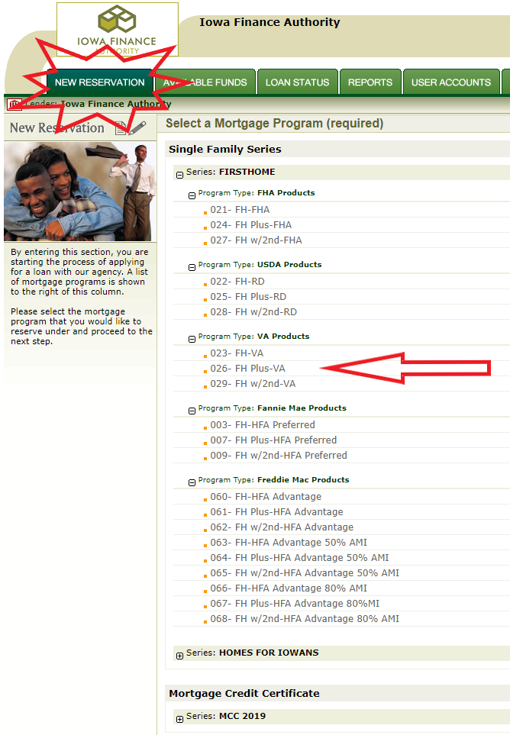
Choose the program type option that best suits your borrower’s needs to get started. These programs will be in order by FirstHome or Homes for Iowans then by Loan type (FHA, RD, VA, Fannie Mae & Freddie Mac).

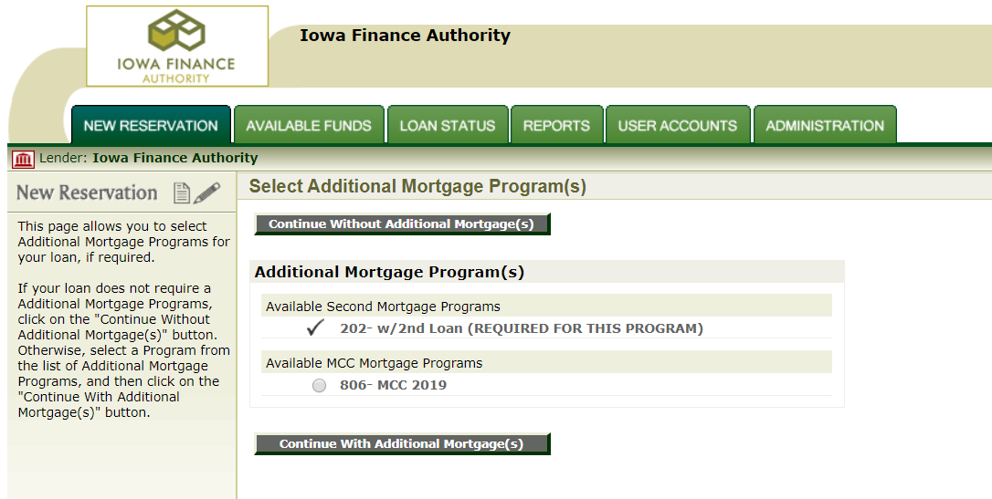
Once you have selected your 1st mortgage loan type, you will be prompted to choose any additional mortgage(s). If you’ve selected a program with Plus grant or 2nd loan, the “2nd” mortgage record will be added automatically.
If using a Homes for Iowans file, you will need to select if you are adding the Mortgage Credit Certificate, if available, before proceeding. Once you have chosen all associated mortgage(s), you will be taken to the reservation screen.

Continue by clicking on “Continue with (or without) additional mortgage(s)”.
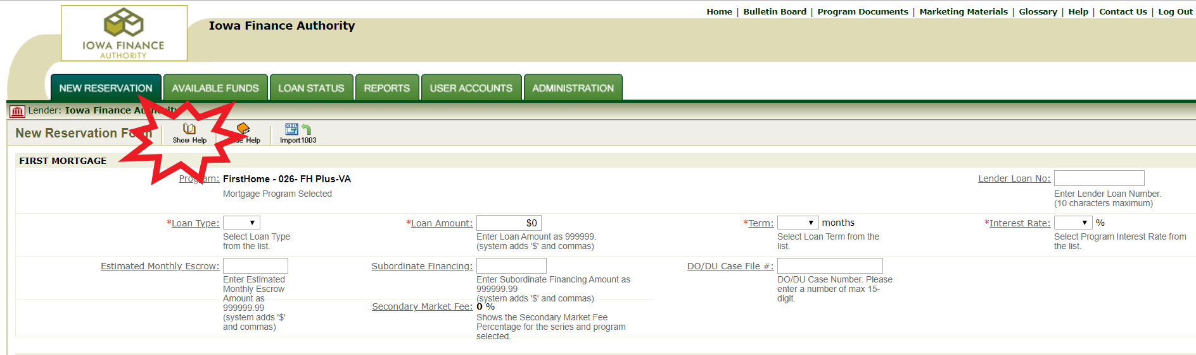
On the reservation form, complete all required loan data fields marked with *. If you are unsure what is needed in the text box, select the underlined title for a description. You may also select the “Show Help” button to display all the descriptions. To remove the descriptions, select “Hide Help”.
To add a Co-Borrower, check the box next to the selection. A tab will open, allowing you to add that person’s information. Reminder, Co-Signers are not allowed on any IFA programs.

When the New Reservation Form is complete, hit Submit at the bottom of the page. The following reservation acceptance will be provided to confirm your reservation.

It is recommended that the lender view or print the reservation by selecting the “Click here” button to serve as a communication tool for the lending team confirming the rate, program, etc.

If you have any questions, please contact one of our Homeownership team members.

Available Funds
Click on the Available Funds tab to check out the Authority's current funding availability in the system. If you are planning to submit a reservation for a program, this is where you can check if sufficient funds are available.
Click on a Series or Program Type from the list of Bond Issues available in the system.
Across the top of the page there is a message indicating the last date and time when the information was last updated. If you are planning to submit a reservation for a program where your available funds may be close to the amount of the reservation, you may click on the Update button.
After a few seconds the information displayed will be updated. If sufficient funds are available, you may proceed to enter a reservation without concern that it will be rejected for lack of funds.

Loan Status
Once the reservation is accepted, you may review your reservation or upload documentation through eDocs at any time in Lender Online. You may search for the loan by using the IFA loan number, Lender Loan No (if added on initial reservation), borrower name or SSN.
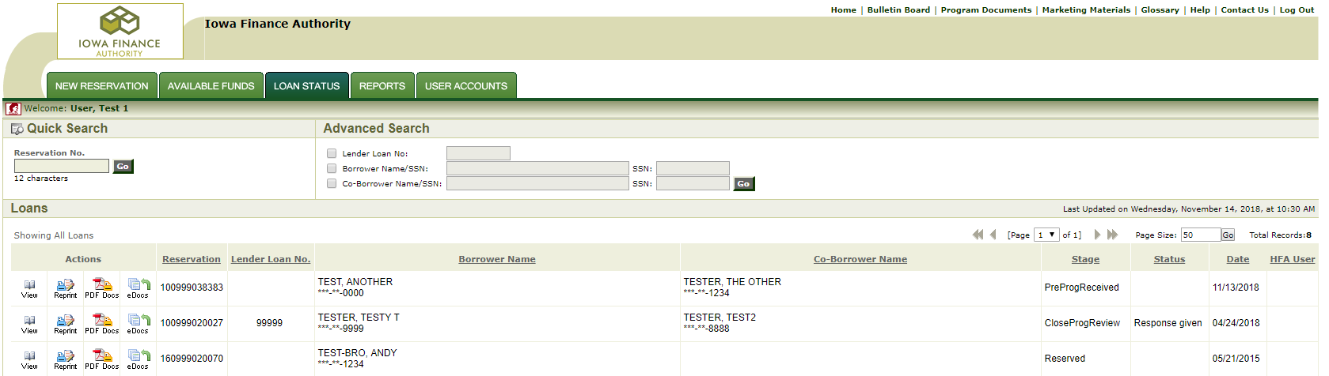
Action buttons:
View: This will take you to the loan details including loan terms, current status, outstanding conditions and IFA file reviewer name.
Re-Print: This will allow you to save or re-print the lock confirmation.

PDF Docs: This will take you to all of the documents associated with this file. You may also generate the Pre-Close and Post-Close transmittal forms here.

eDocs: This will take you to our secure document portal to upload and submit your documents for IFA review.

View
If your eligibility review has been complete, you’ll be able to find the stage, status and date of review by clicking on the “VIEW” icon. Scroll down to the Stage/Status/Date section on the right side. It will show PreProgReview (or CloseProgReview) with one of the following statuses -

Response Given: This mean Program Specialist has reviewed and completed requested program change.

Incomplete: This means lender will need to submit additional documentation on file to complete IFA eligibility review. It is common for IFA to add “INC” to those conditions needed.

Approved: This means IFA has issued the Pre-Close Commitment for this reservation via email.

Here are the individual stages you will find -
Reserved: Lender created reservation
PreProgReceived: Pre-Close package is uploaded and submitted
PreProgReview: Program Specialist has completed review
CloseProgRecvd: Post-close package is uploaded and submitted
CloseProgReview: Program Specialist has completed review
Committed: All conditions have been met and file submitted to Master Servicer
MS Purchased: Purchased by Master Servicer

HFA Conditions/Exceptions
If your eligibility review has been complete, you’ll be able to find the HFA Conditions/Exceptions to review by clicking on the “VIEW” icon. It is recommended you print this page and keep in your loan file.

If the above Stage/Status indicates Approved, the conditions listed may be submitted under Post-Close Package at the same time you upload your Post-Close documents. Once Pre-Close Approved, you can proceed with closing.

If the reservation is Incomplete, the conditions will need to be met prior to closing. Any additional documents that are needed will be uploaded to the Pre-Close Loan File section in eDocs. You’ll receive an email once the review is complete.

Reprint
The Reprint button is used to print a copy of the accepted reservation.

PDF Docs
The PDF Docs button is where you will find the documents necessary for the transaction, including the Pre- and Post-Close Transmittals. These documents are pre-filled based on the data entered into reservation. Click on the box next to the individual document(s) you would like to print and select Generate Documents. Under Generated Documents, you can select the document to open and print, or select the Print ALL Documents button.

eDocs
Select the eDocs action button associated with borrower file to upload documents to IFA. You will find two packages: Pre-Close and Post-Close. Please ensure the transmittal form with lender’s contact information (specifically email address) is uploaded with initial submission.

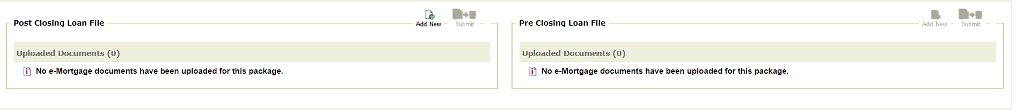

Uploading Pre-/Post-Close Eligibility Package
To upload a Pre- or Post-Close eligibility file, choose “Add New” under specific package.
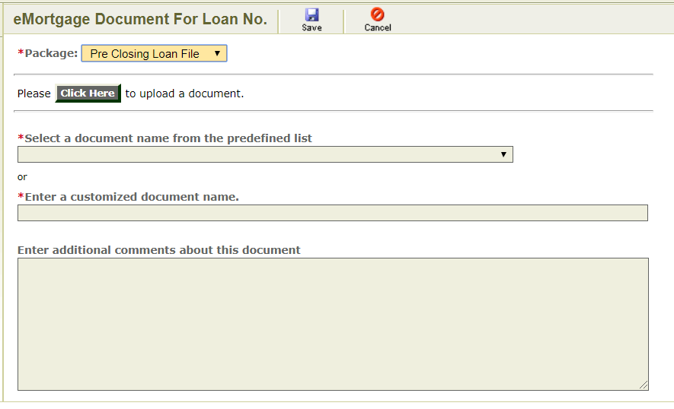
Locate your document(s) to upload by selecting the “Click Here” button. The document upload will take a minute. Once it tells you “Document (NAME) has been successfully uploaded, you may proceed with naming the document. YOU ARE NOT DONE YET!

Naming the document may be done two ways:
- Select name by clicking the predefined list, OR
- Enter a customized document name.
If you are uploading the documents one by one, please label them individually. Do not name each package “Pre-Close (or Post-Close) Package”.
Lastly, if you have any notes/comments for your IFA reviewer, please add them to the comment section. These comments do not act as a letter of explanation (LOX).

When you are finished, click the “SAVE” button at the top. You are NOT done yet!!

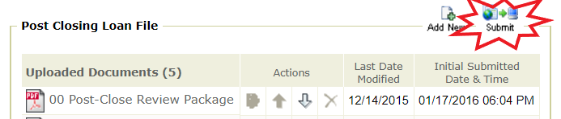

Once your document(s) is/are uploaded and saved, you will return to the e-Mortgage Docs page. Here you will find the “SUBMIT” button is now lit up. IMPORTANT: You MUST click SUBMIT to transmit your uploaded documents to IFA for eligibility review.
To confirm your documents transmission was successful, you will get this message after uploading -
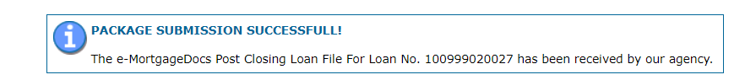

Additionally, you will find the Initial Submitted Date & Time box has been filled in.
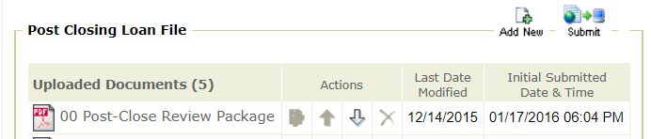

Your IFA Program Specialist (HFA reviewer) will review documents uploaded and submitted in order of receipt. Note: Any additional documents submitted before initial review has been completed, will restart your review time based on most recent submission.

An email from your IFA Program Specialist will be sent once the review is complete. This email will let you know what time the reservation will be available for you to review. At the specified time, you may locate the reservation under Loan Status and click on “VIEW” icon.

Reservation Change
If a change is necessary after the initial reservation has been created, complete a loan reservation change form and upload through eDocs in Lender Online. This form is available in Lender Online under Loan Status by clicking on the PDF Docs icon associated with borrower records. You may also locate by clicking on Program Documents at the top of the page. These requests will be processed within one business day of submission.

Examples of such changes may be loan amount, sale price, loan type, cancellation, etc. A request for cancellation and new reservation for an existing Borrower will not be permitted unless the property has changed, or the original expiration date has exceeded ninety (90) days. If the current
reservation expiration date has not exceeded ninety (90) days, the existing reservation will remain and be subject to IFA’s relock policy. For additional information, refer to our Homeownership Rate Lock Policy available on the IFA website.

NOTE: Once the reservation has been Pre-Close approved, any changes must be uploaded under the Post-Close loan file section.

Reports

There are several reports available Lender Online specific to the individual lender’s portfolio. First, select the report you need.

Conditions/Exceptions Report:
This report lists all loans that are under review and have incomplete or missing information, leading to exceptions. Selecting the Conditions/Exceptions Report link will take you to a page that allows you to customize the report. After you customize the report, press the Submit button. This will present you with a list of all the loans with conditions/exceptions, which also meet your selection criteria, organized as you specified in the customizing step. Clicking on the Reservation Number link will take you to the Loan Status page where detailed information is given.
Commitment Expiration Report:
This report lists all loans that have a commitment expiration date within a date range you can specify. Selecting the Commitment Expiration Report link will take you to a page that allows you to customize the report. After you customize the report, press the Submit button. This will present you with a list of all active loans with a commitment expiration date in the date range you specified, which also meet your other selection criteria, organized as you specified in the customizing step. (Active loans do not include loans that have been cancelled, rejected, purchased or placed in a waiting list). Clicking on the Reservation Number link will take you to the Loan Status page where detailed information is given.
Current Stage Status Report:
This report presents comprehensive information on loans, which you may select according to the status of the most current loan tracking stage. Selecting the Current Stage Status Report link will take you to a page that allows you to customize the report. After you customize the report, press the Submit button. This will present you with a list of all the loans that meet your selection criteria, organized as you specified in the customizing step. Clicking on the Reservation Number link will take you to the Loan Status page where detailed information is given.
Demographics Report:
This report presents in graphical form demographics data for the purchased loans selected according to a demographic characteristic. The loans are selected by choosing the criteria: Bond Program, County and Zip Code. You may select an individual item (Detail) or a group of items (Summary). When a group of bond programs, or a group of counties is selected you may assign a custom title to the report. You may select which characteristic(s) you wish to see displayed. By clicking first on one of the four groups: Borrower, Household, First Mortgage Loan or Property. When you select a group, the default is to select all the individual characteristics in each group. You may deselect anyone you do not wish to display by clicking on the check box.
Customizing a Report
After you select any of the report types, you are presented with one or more selection boxes where you can narrow the scope of the search to give you only loans meeting your specific criteria.
The number and type of selection boxes presented to you depends on the type of report selected and your level of authorization. The process is organized in steps that you follow, ending with a place where you can click on the Run Report button to generate the report.
The selection boxes default to All so that, if you do not select any given criterion, you will be presented with the maximum number of loans available to you. To select individual items, use the Select radio button and/or the Add button. To delete individual items, use the Remove button.
Range Filters, like date periods, allow you to run the reports for a closed range, from a starting point, or up to an ending point.
The Sort Criteria section provides you with the flexibility of being able to sort and group your report by the desired criteria, as well as breaking a page or not after the end of a group. This is a powerful tool that will take some practice to perfect.
Printing a Report
After you click on the Run Report button, the system will pop up a window with a message reflecting that the report is being generated and a counter.
Once the report has been completely displayed, you can click on the Printer icon from the Toolbar of your browser, or select Print from the File menu of your browser.

User Accounts
Under User Accounts, you may modify your own personal information and change password. Your lending institution has been assigned system administrator. Your system admin is responsible for set up of team members, including roles, usernames and passwords. Once you have received your username and password from your system admin, you may log into the system.

Change Password
Click on the User Accounts tab then click on the Change Password link. This will bring you to a page where you can enter and confirm your New Password. Due to security reasons, your new password must be unique and contain at least six characters with upper and lower caser letters/numbers.
If your account is locked, you will need to contact your system admin to unlock it for you.

User Access Levels (Roles)
Contact Only Level (No access):
These individuals do not have access to the system. They will appear at the bottom of the 'New Reservation' page, as an informational field.
View Documents Only
Can view bulletins and program documents information.
View Reports Only
Can view bulletins, program documents, and loan status information. Can run and print reports.

Clerk
Can view bulletins, program documents, and loan status information. Can enter reservations.

Officer
Can view bulletins, program documents, and loan status information. Can run and print reports, but only for loans associated with the officer as an individual. Can enter reservations.
Branch
Can view bulletins, program documents, and loan status information. Can run and print reports, but only for the branch of the lender institution that the user belongs to. Can enter reservations.
Can authorize other users to access the system at the 'Branch' or lower levels. (Only when the Admin checkbox is checked)
Lender Level
Can view bulletins, program documents, and loan status information. Can run and print reports for the entire lender institution. Can enter reservations. Can authorize other users to access the system at the 'Lender' or lower levels. (Only when the Admin checkbox is checked)

HFA View Only
Can view bulletins, program documents, and loan status information. Can run and print reports for all the participating lender institutions of the system.
HFA Reservation Entry
Can view bulletins, program documents, and loan status information. Can run and print reports for ONE entire lender institution at a time.
Can enter reservations.
Can authorize other users to access the system at the 'HFA View Only' or lower levels.

NOTE: If you are needing to update your access level, please contact your system administrator within your lending institution.

