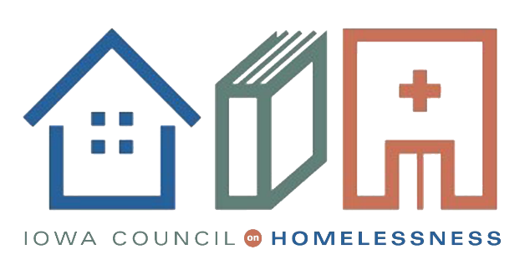

Dear Secretary Carson:

We write today as housing professionals and members of the Iowa Council on Homelessness to voice our dissent from the July 24 HUD proposal to remove protections for transgender people seeking shelter under the 2016 Equal Access Rule. To the extent that this decision is based in the safety of shelter guests across the country, know this: every one of us cares about safety in America’s shelters. Individuals are safest when all women—whether transgender or cisgender—are housed together and when all men—again, whether transgender or cisgender—are housed together. Similarly, nonbinary individuals should be housed with their preferred cohort.
This is not just local opinion. The national experts on homelessness, sexual assault, and domestic violence agree. In fact, as recently as 2016, the National Task Force to End Sexual and Domestic Violence Against Women released a statement co-signed by over 300 national and local providers. The statement affirms in part that, "States across the country have introduced harmful legislation or initiatives that seek to repeal non-discrimination protections or restrict transgender people’s access to gender-specific facilities like restrooms. Those who are pushing these proposals have claimed that these proposals are necessary for public safety and to prevent sexual violence against women and children. As rape crisis centers, shelters, and other service providers who work each and every day to meet the needs of all survivors and reduce sexual assault and domestic violence throughout society, we speak from experience and expertise when we state that these claims are false." This is not as simple as pressing pause on a rule change that would unnecessarily restrict services to transgender and nonbinary individuals to limit a fictional harm to cisgender individuals. Rather, this proposed rule change would not only not protect the cisgender community; it would actively harm the transgender community.
Let us explain. In 2015 the National Transgender Discrimination Survey reported that nearly a quarter of all respondents experienced housing discrimination in the previous year. Of those who experienced homelessness in the previous year, more than one quarter avoided staying in a shelter because they feared being mistreated as a transgender person. Of those who did seek and receive shelter, 70 percent reported harassment, sexual or physical assault, or removal due to their status as transgender.
When we look at lifetime statistics, the numbers are even more grim. One out of every three transgender and nonbinary people experience homelessness at some point in their lives, but that rate increases to nearly one out of every two for transgender and nonbinary people who identify as black, middle eastern, multi-racial, or undocumented.
As you know, access to safe and secure housing is sometimes all that stands between transgender people and deadly violence. And that violence is not evenly proportional within the non-cisgender population; rather, it vastly disproportionately affects transgender people of color. The Human Rights Campaign’s research shows that a staggering 91 percent of victims of fatal anti-transgender violence in 2019 were black women.
That the proposed rule will permit staff trained in service provision, not gender discernment, to assess gender and provide or deny shelter accordingly is both risk and liability. This ad hoc assessment and denial put not only transgender and nonbinary individuals at risk, but cisgender individuals as well. This is particularly problematic in cases where an individual might not present as clearly masculine or feminine.
What a thing, to be denied shelter in a time of desperate need because you do not look man enough or woman enough. It will be an excuse to turn people away and into the cold simply based on their gender expression or physical attributes. People will literally die from having the "wrong" gender characteristics, whatever that happens to mean to any particular staff member at one particular time.
The decision to allow this rescission is unconscionable.
To be clear, Secretary Carson, nondiscrimination laws protecting transgender people have existed for a long time. Over 200 municipalities and 18 states (including Iowa) have nondiscrimination laws protecting transgender people’s access to facilities consistent with the gender they live every day. In some cases, these protections have been in place for decades. These laws have protected people from discrimination without creating harm. None of those jurisdictions have seen a rise in sexual violence or other public safety issues due to nondiscrimination laws.
The victim service providers in our state have also come out against these changes, stating that these types of policy changes are not really about safety, or that housing transgender with cisgender people—even with children—puts the cisgender people/children at risk. All data and evidence in their Iowan experience shows that it does not. Our well-established emergency shelter and housing providers, some of which have decades-long histories of treating housing as a human right, go about this by also treating all people with humanity and dignity. To add this superfluous level of bureaucratic barrier is directly disrespectful to the provider community and their already overworked and dedicated staff, for whom we also write this dissent.
This feedback is intended to reflect the very spirit of Iowa’s generosity and the famous Midwest compassion of which we all take pride. A compassion which obligates all of us to care for those in need, without question, and always with dignity and respect.
We do not see these values reflected in this proposed rule change, nor does this seem the role of your Department, which has been charged with creating strong, sustainable, inclusive communities and quality affordable homes for all. We implore you to reverse course and preserve the 2016 Equal Access Rule in its entirety.
We thank the Iowan community partners and non-profits who worked together to prepare this thoughtful feedback during a time not only of national pandemic but also historic damage from a national disaster, proving the importance of this topic and of our words.
Contributors: OneIowa.org, Shelter House Community Shelter and Transition Services, ACCESS, and Institute for Community Alliances
Sincerely,
Ashley Odom
Chair of Iowa Council on Homelessness

