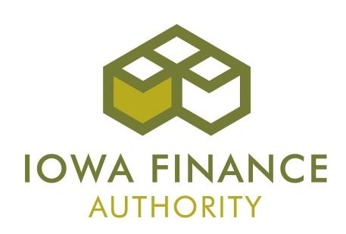

MINORITY IMPACT STATEMENT

Pursuant to 2008 Iowa Acts, HF 2393, Iowa Code Section 8.11, all grant applications submitted to the state of Iowa that are due beginning January 1, 2009 shall include a Minority Impact Statement. This is the state’s mechanism for requiring grant applicants to consider the potential impact of the grant project’s proposed programs or policies on minority groups.

Please choose the statement(s) that pertains to the grant application. Complete all information requested for the chosen statement(s).

The proposed grant projects programs or policies could have a disproportionate or unique positive impact on minority persons.

Describe the positive impact expected from this project:

Indicate which group is impacted:
Women Persons with a Disability Blacks
Latinos Asians Pacific Islanders
American Indians Alaskan Native Americans Other

The proposed grant project programs or policies could have a disproportionate or unique negative impact on minority persons.

Describe the negative impact expected from this project:

Present the rationale for the existence of the proposed program or policy:

Provide evidence of consultation with representatives of the minority groups impacted:

Indicate which group is impacted:
Women Persons with a Disability Blacks
Latinos Asians Pacific Islanders
American Indians Alaskan Native Americans Other

The proposed grant project programs or policies are not expected to have a disproportionate or unique impact on minority persons.

Present the rationale for determining no impact:

I hereby certify that the information on this form is complete and accurate, to the best of my knowledge:

______________________________________ Click here to enter text.
Signature Typed/Printed Name:

Title: Click here to enter text.
DEFINITIONS

“Minority Persons,” as defined in Iowa Code Section 8.11, mean individuals who are women, persons with a disability, Blacks, Latinos, Asians or Pacific Islanders, American Indians, and Alaskan Native Americans.

“Disability,” as defined in Iowa Code Section 15.102, subsection 5, paragraph “b,” subparagraph (1): b. as used in this subsection:
(1) “Disability” means, with respect to an individual, a physical or mental impairment that substantially limits one or more of the major life activities of the individual, a record of physical or mental impairment that substantially limits one or more of the major life activities of the individual, or being regarded as an individual with a physical or mental impairment that substantially limits one or more of the major life activities of the individual.
“Disability” does not include any of the following:
(a) Homeosexuality or bisexuality.
(b) Transvestism, transsexualism, pedophilia, exhibitionism, voyeurism, gender identity disorders not resulting from physical impairments or other sexual behavior disorders.
(c) Compulsive gambling, kleptomania, or pyromania.
(d) Psychoactive substance abuse disorders resulting from current illegal use of drugs.

“State Agency,” as defined in Iowa Code Section 8.11, means a department, board, bureau, commission, or other agency or authority of the state of Iowa.

